|  |
| --- |
| Data Analyst Training |
| Assignment Week 1 - 3 |

|  |
| --- |
| 07 January 2024 | By: Lami Hadiza George |



|  |
| --- |
| Table of Contents  Assignment 1 Data Visualisation 2  Task 1: Policies and Procedures 2  Task 2: Excel 2  1. Set a password to protect the workbook. 2  2. Highlight column C and change the data to display in British Pound 4  3.Turn the GDP sheet into a table. 6  4. Filter the table to display only the information for 2019 6  5. Next create a chart that will only display the following data ‘Rank, 7  6. Using your creative skills edit the chart 8  7. Move the chart to a new sheet tab and label with a suitable name. 10  8. Create a sort for the top 20 highest ranking countries. 11  9. Next create a new Bar chart to display the 20 highest ranking countries from the sort. 15  10. Colour the background by highlighting the area underneath the table as shown below. 17  Task 3 - Tableau 18  1. Import Data 18  2. Set Relationships 18  3.Data Types 19  4. Build charts 20  Judging Criteria 31 |

# Assignment 1 Data Visualisation

## Task 1: Policies and Procedures

It is extremely important for data analysts to be aware of privacy, security, retention, ethics, and licensing policies when working with any datasets.

Data analysts need to be cognisant of and comply with organisational data protocols allowing data analysts to produce higher quality work product, uphold critical ethical principles, avoid legal repercussions, and cultivate positive perceptions of their integrity over the long term.

Here are some key reasons:

1. Compliance - Data analysts must comply with organisational data protocols and best practices around handling sensitive information to avoid regulatory penalties, lawsuits or loss of public trust.
2. Privacy Protection - By following privacy policies and properly anonymising data, analysts uphold ethical obligations and prevent unauthorised exposure of personal information that could cause harm to individuals and groups.
3. Data Integrity - Careful adherence to security, retention and licensing policies helps analysts ensure the accuracy, completeness, consistency, and overall integrity of the data they utilise for analysis.
4. Accountability - Understanding these data policies makes analysts accountable for securely and responsibly collecting, storing, analysing, attributing, and sharing data as they carry out their duties.
5. Research Credibility - Executing analysis of the "Wealth of Nations" data in line with strong ethics guidelines helps analysts generate more credible, unbiased, and meaningful insights that stand up to scrutiny.
6. Career Impact - Analysts who consistently exercise care and consideration around data protection and stewardship build superior reputations for trustworthiness that can influence their professional advancement.

## Task 2: Excel

### Set a password to protect the workbook.

First save the File with a different name or in a different location.

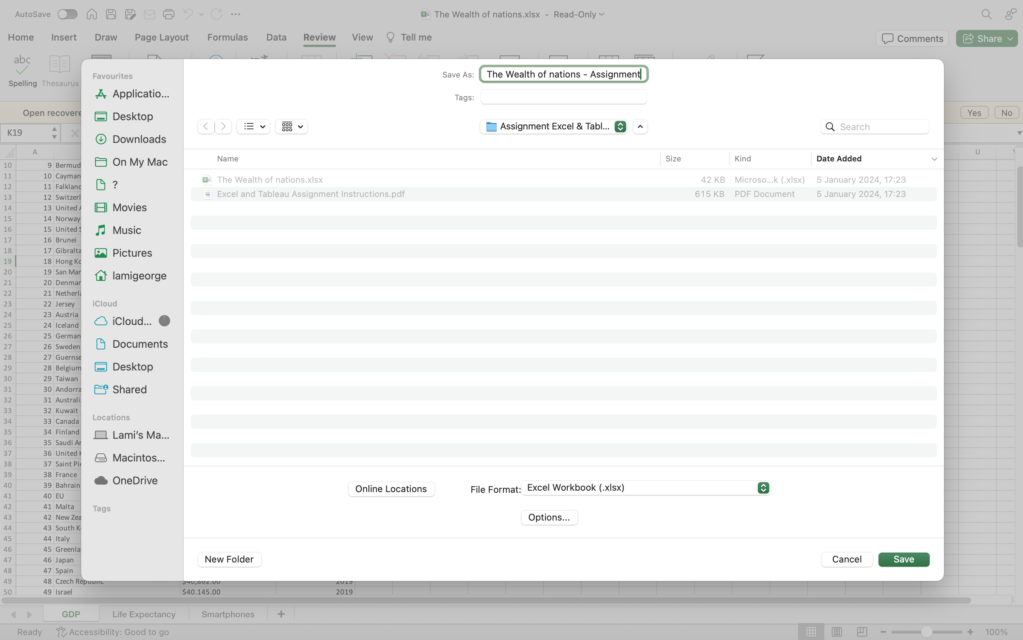

Next select, the review Tab and then protect workbook.

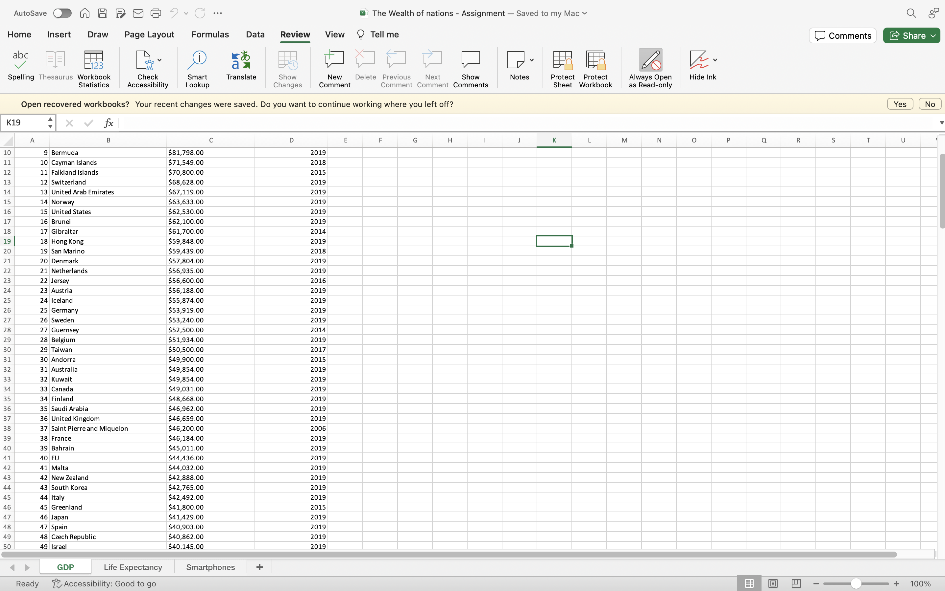

Enter a password and verify. This password will be needed to move sheets, delete sheets, hide sheets, unhide sheets or rename sheets. To insert new sheets the password will be required.

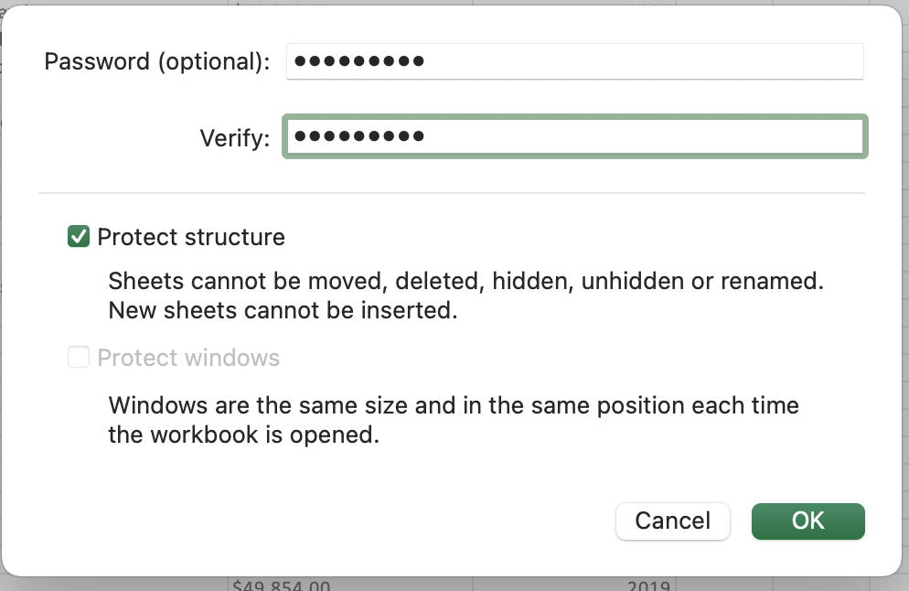

### 2. Highlight column C and change the data to display in British Pound

Symbol

Highlight column C, right click and select format cells.

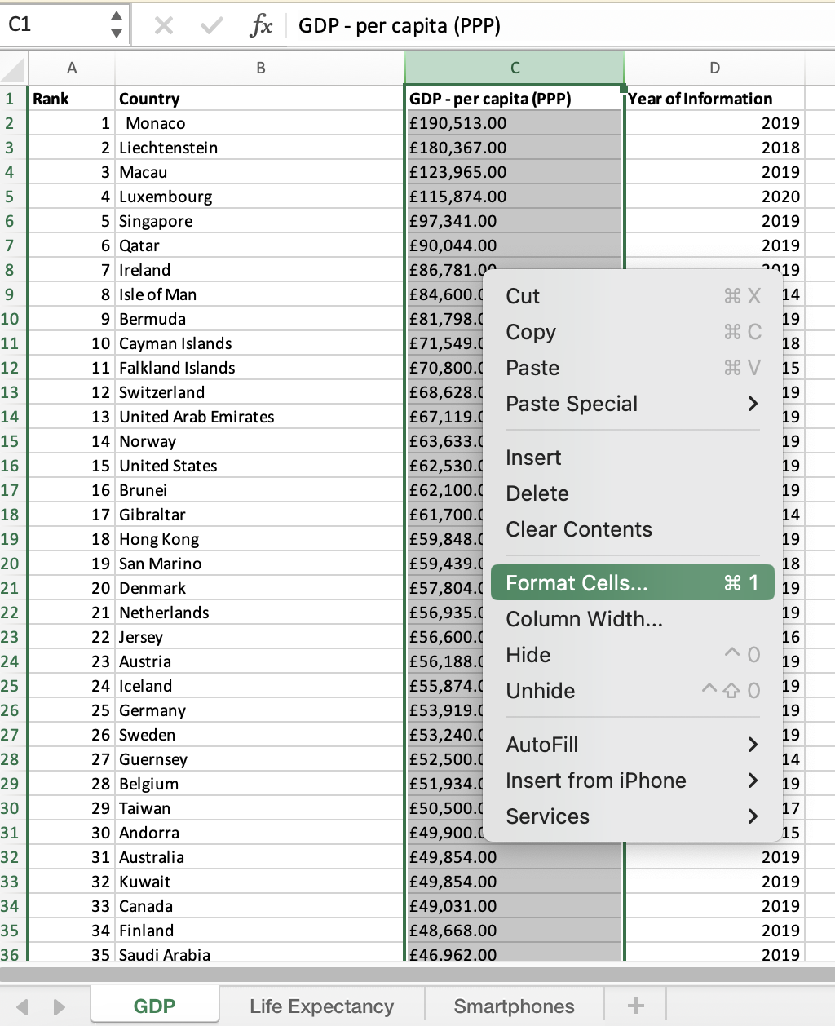

From the format cell overlay, select currency, then the British Pound symbol and select ok to confirm.

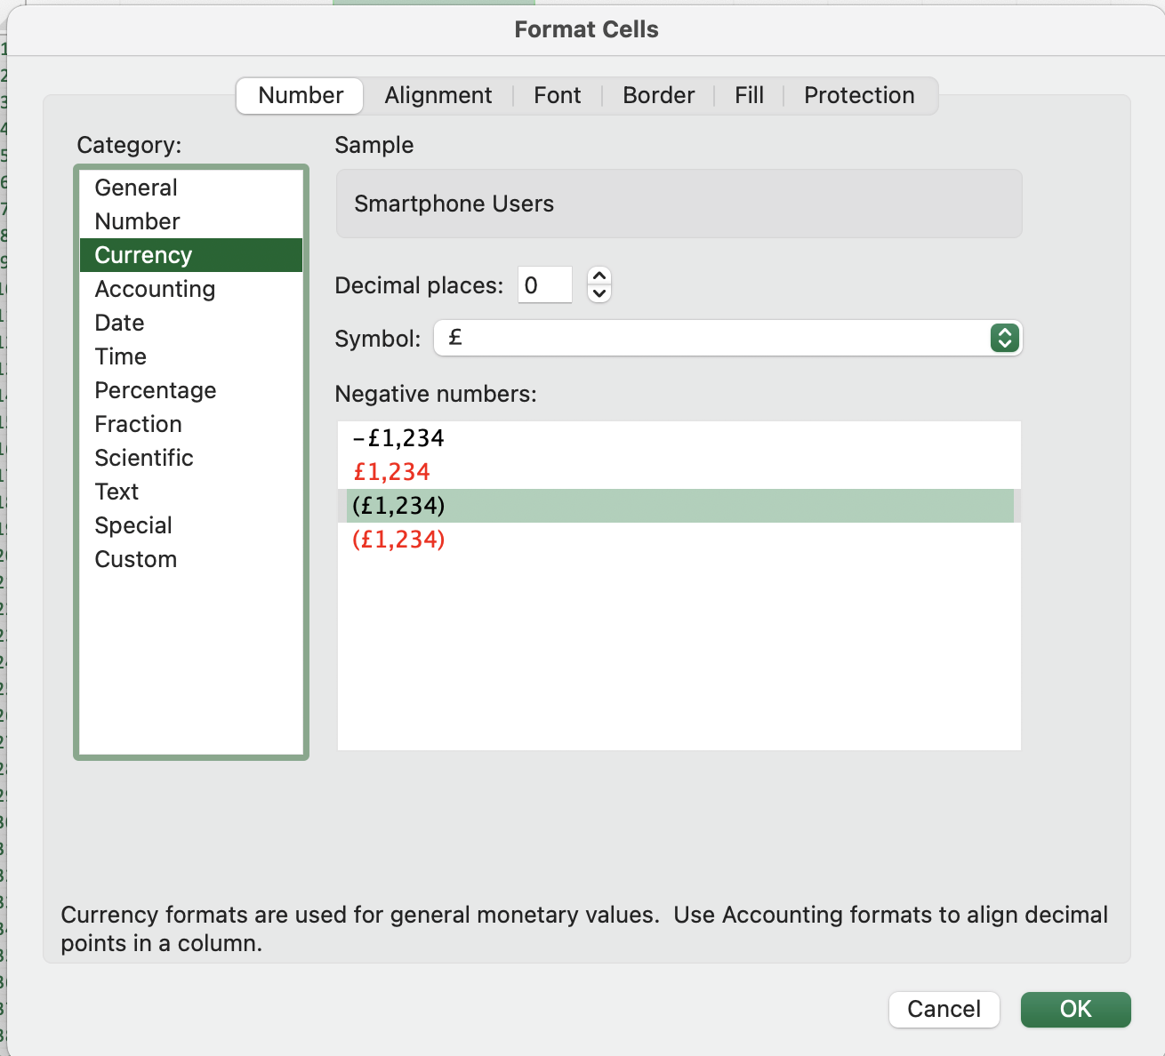

Alternatively, highlight column C, and from the Home Tab menu, you’ll see custom, select Currency.

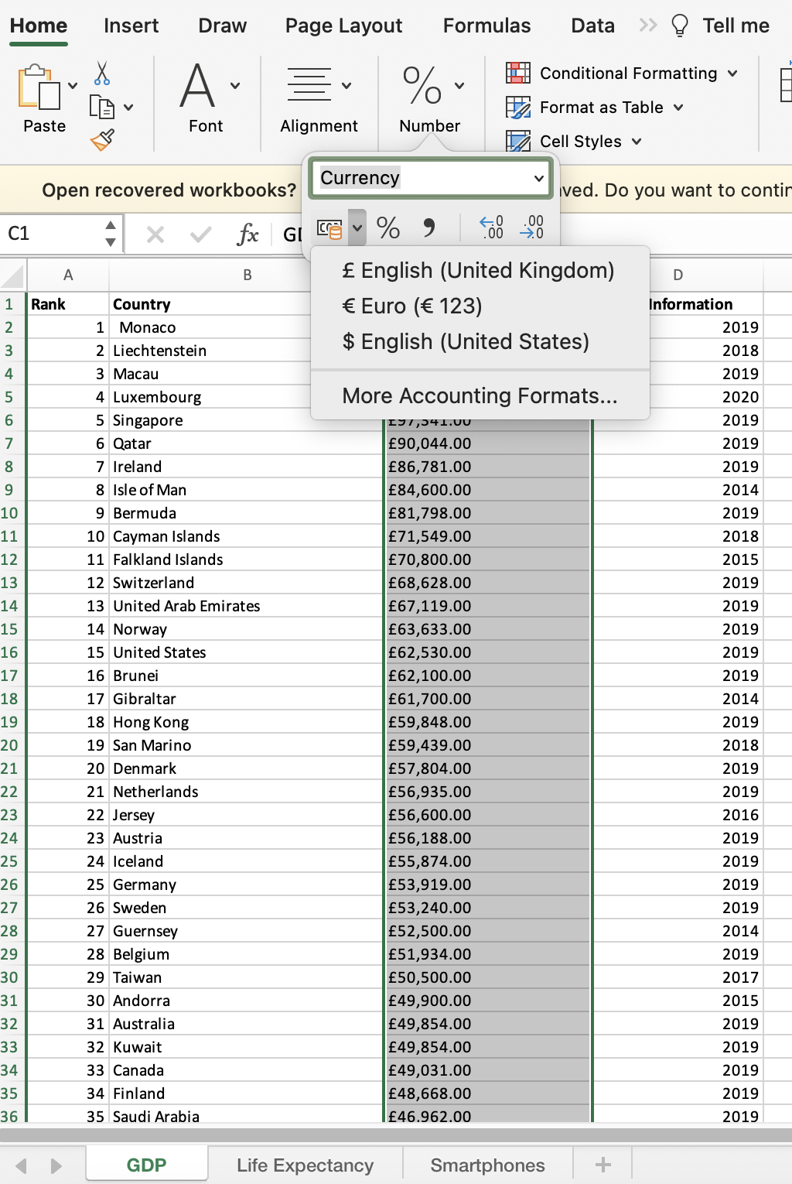

### 3.Turn the GDP sheet into a table.

Select the Insert menu and select table. Confirm the range showing is correct for your data, ensure my table has headers is ticked if you have column headers.

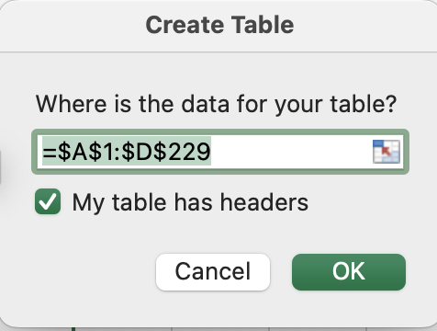

On confirming your table should be formatted to a table:

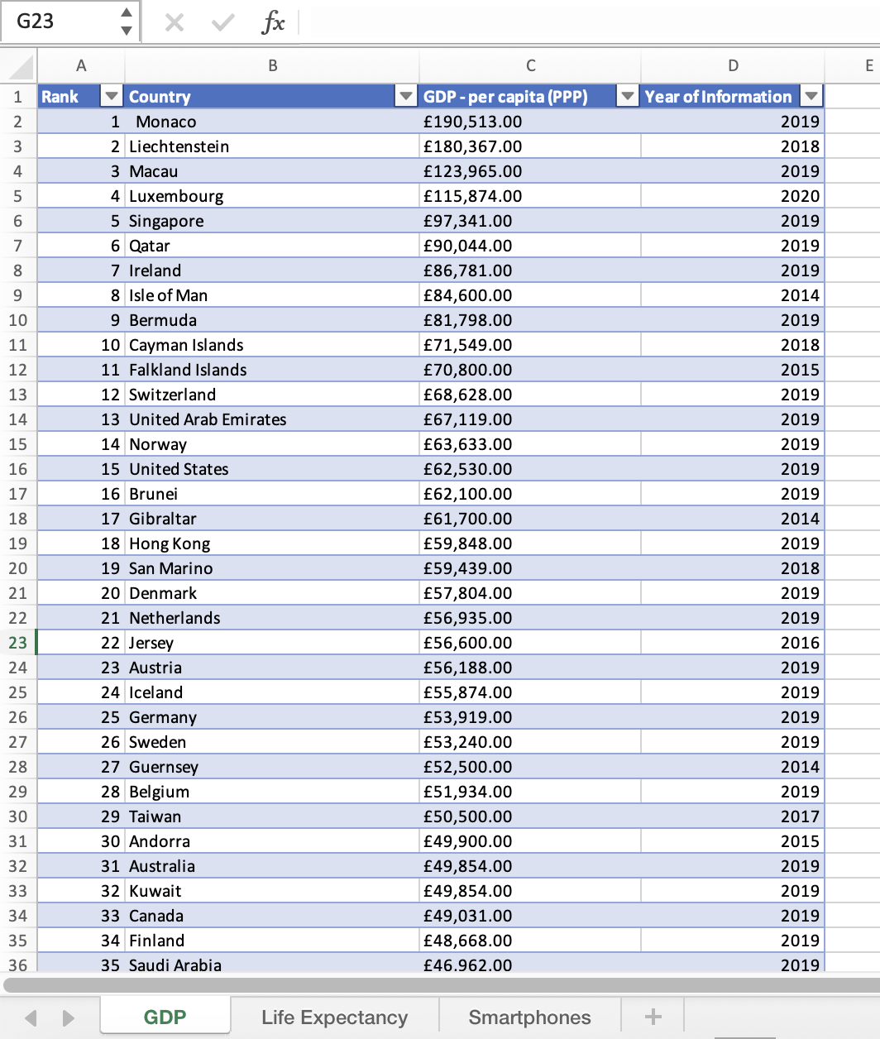

### 4. Filter the table to display only the information for 2019

Select the filter dropdown arrow in the header of column D ‘Year of Information’, Deselect the select all option and select the year 2019. Select ‘Apply Filter’ to display data for the Year 2019 only.

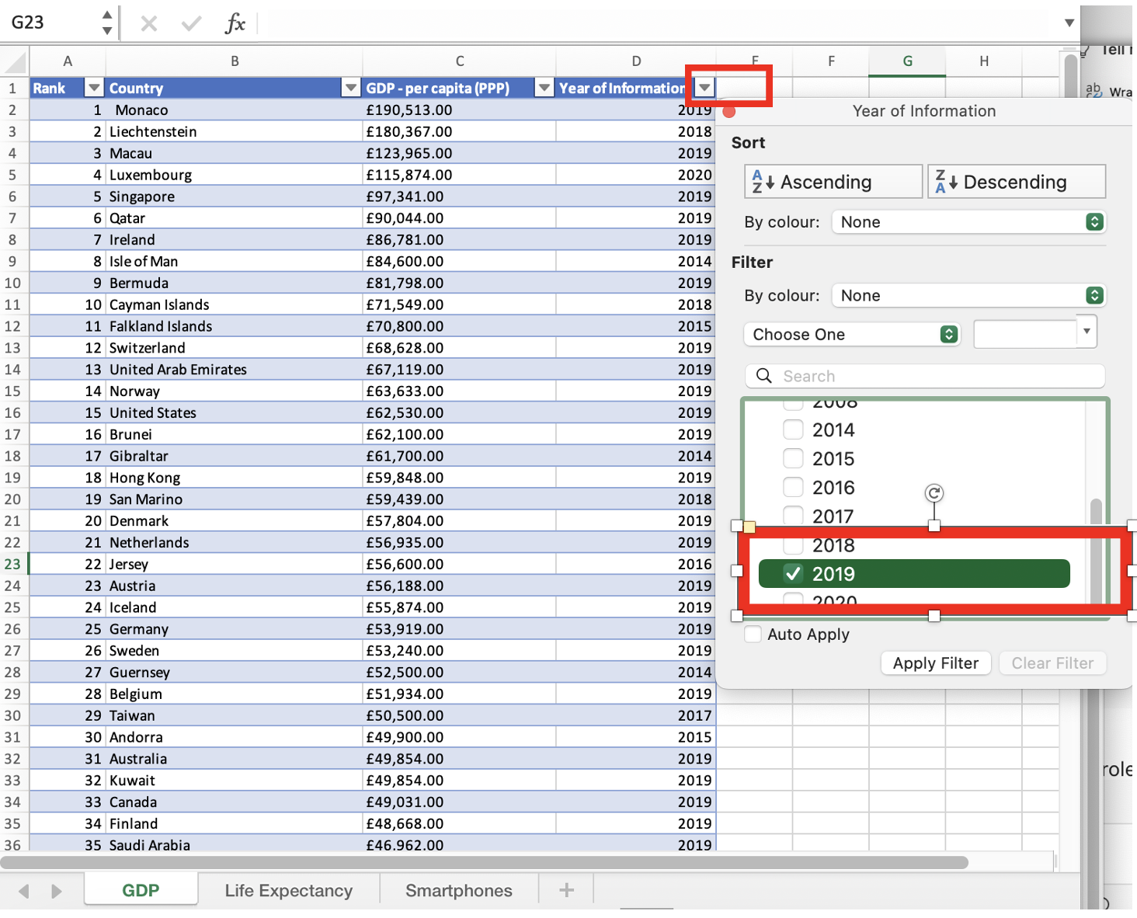

### 5. Next create a chart that will only display the following data ‘Rank,

Country and GDP – per capita (PPP). The chart can be anything as long as it is suitable.

* With the data filtered on Year 2019, select the Ran, Country and GDP – per capita (PPP).
* Select the data, then from the insert menu select chart. Column chart was selected.

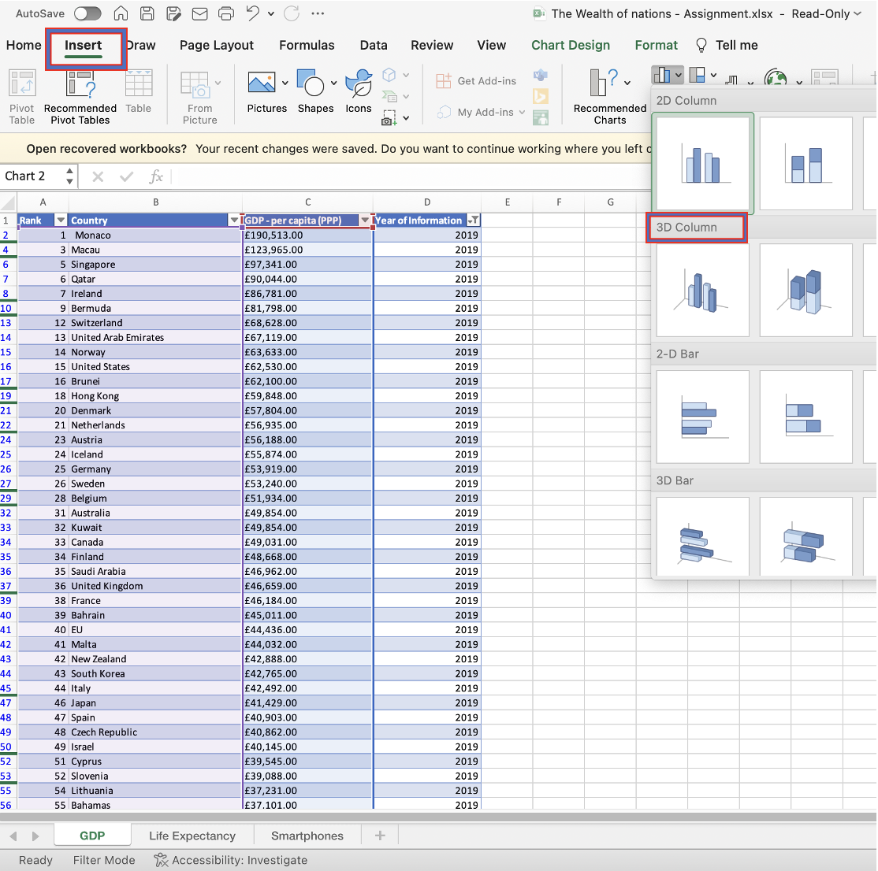

### 6. Using your creative skills edit the chart

a. Add a title

Select the default title and change it.

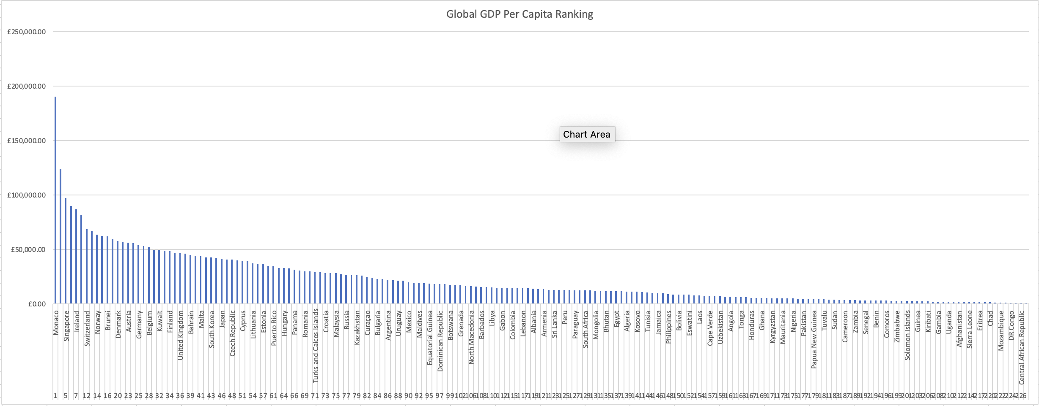

b. Add X and Y axis labels. Make the chart visually pleasing.

Select the chart design. Select Axis title. Click on the chart elements button to display a list of options. Select the Axis Titles and add the primary vertical and horizontal titles.

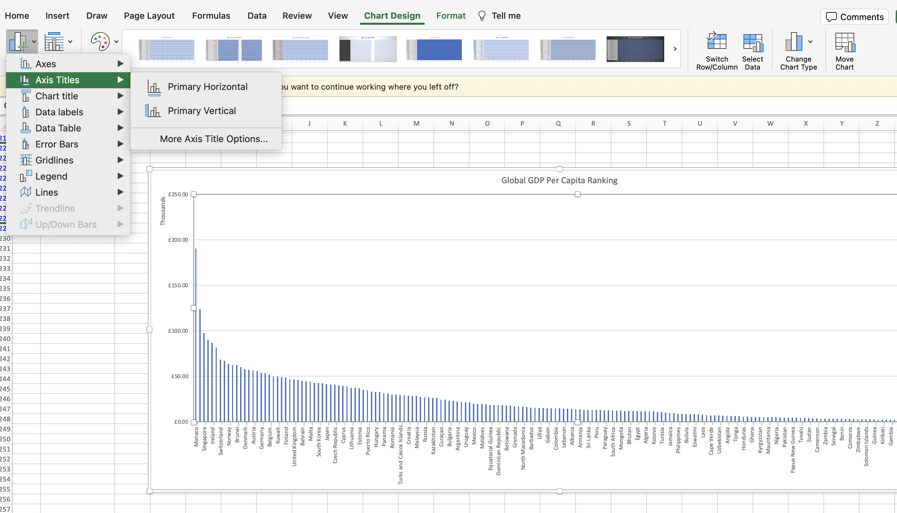

### Move the chart to a new sheet tab and label with a suitable name.

Enter the password to Unprotect the sheet.

Right click on the chart and select the move chart option.

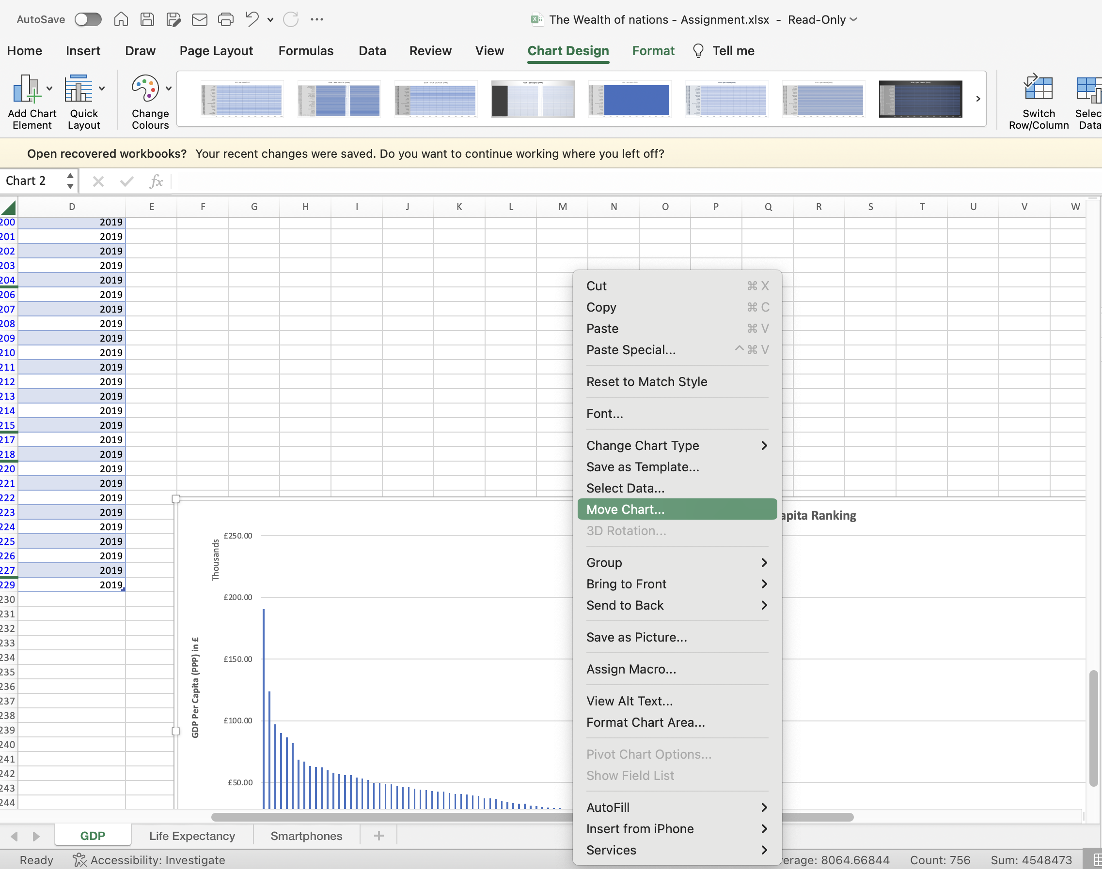

Select move to New Sheet

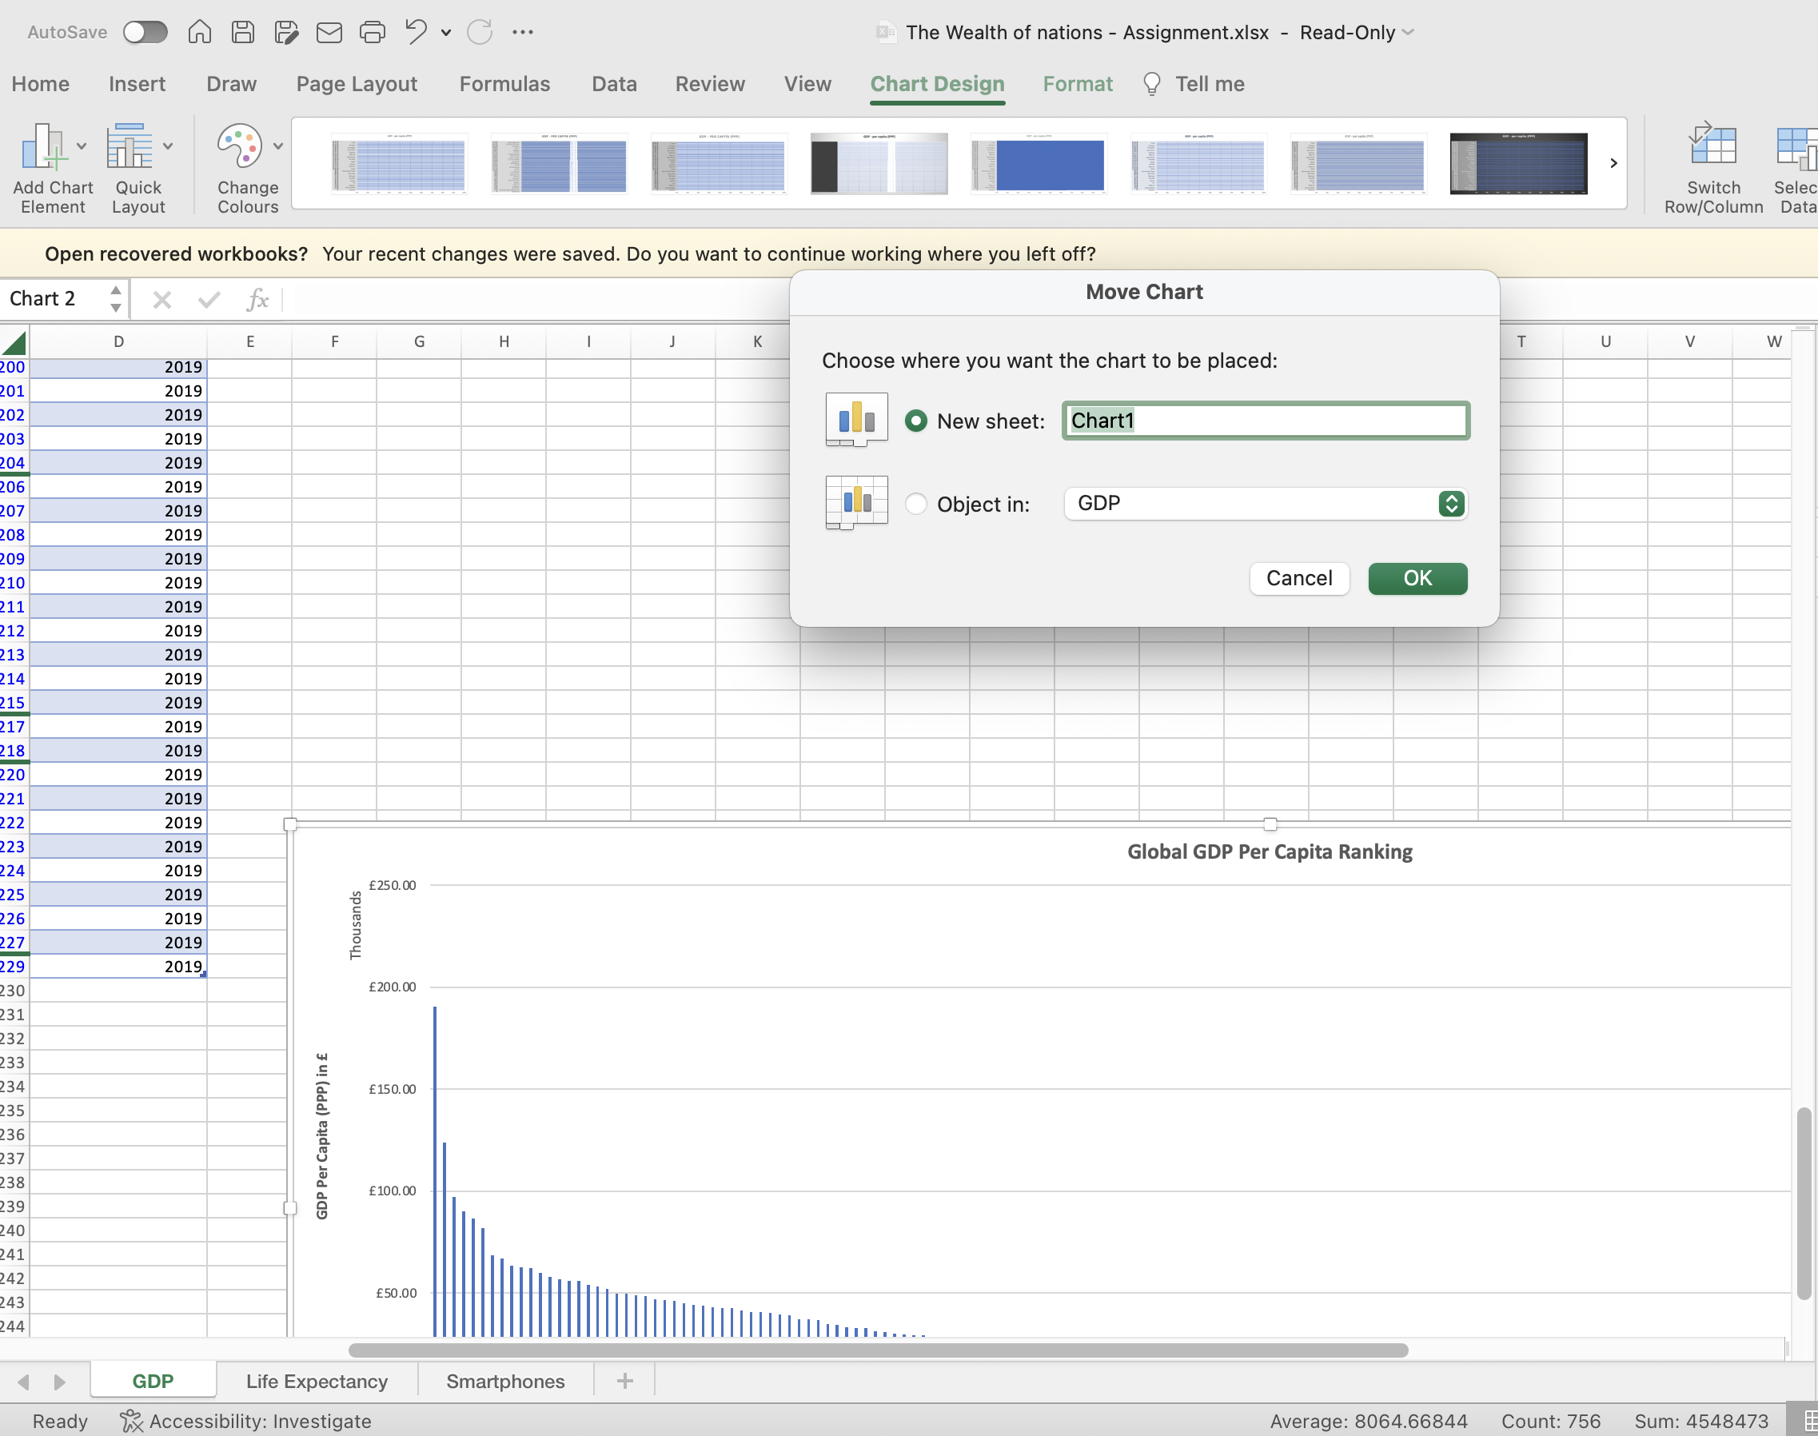

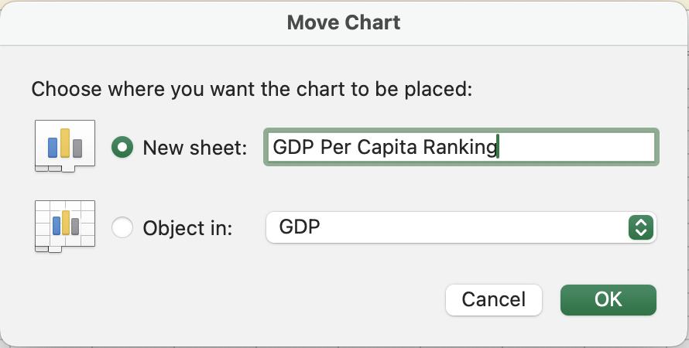

A new sheet is created with the chart.

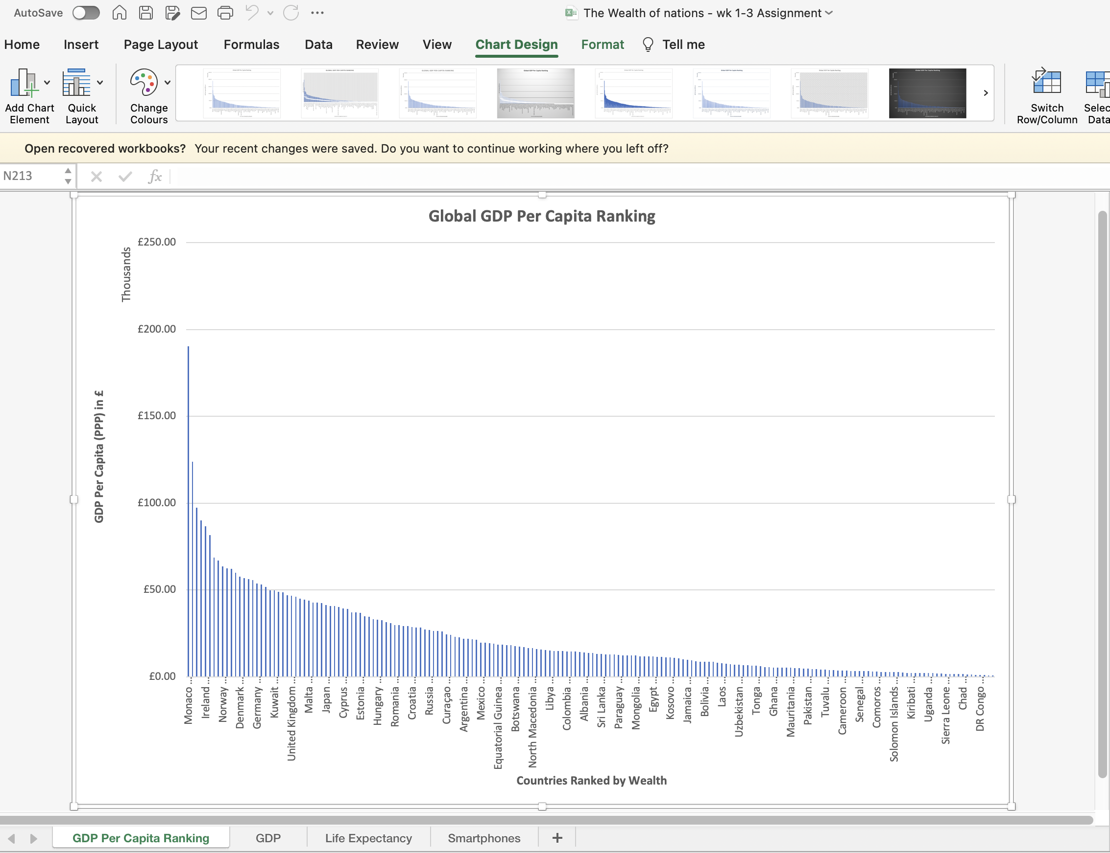

### Create a sort for the top 20 highest ranking countries.

Start by creating a pivot table.

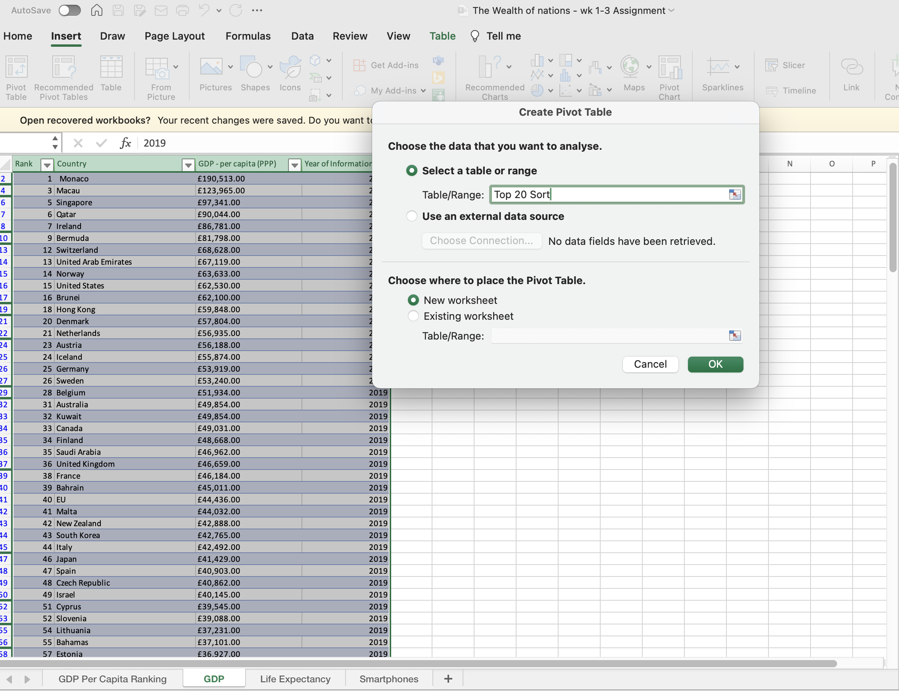

* Highlight the range of data to include in the pivot table. Make sure to include the column headers (i.e., 'Rank', 'Country', and 'GDP - per capita (PPP)'). If data range is formatted as a table, simply click any cell within the table.
* Go to the 'Insert' tab on the Excel ribbon.
* Click on the 'PivotTable' button. Excel will automatically select the data for the pivot table if you've selected any cell inside your data range.
* In the 'Create PivotTable' dialog box, choose where you want the PivotTable report to be placed. You can place the pivot table in a new worksheet or in an existing worksheet.
* Click 'OK', and Excel will create a blank pivot table, and you will see the 'PivotTable Fields' pane appear.
* In the 'PivotTable Fields' pane:
  + Drag the 'Country' field to the Rows area. This will list all countries.
  + Drag the 'GDP - per capita (PPP)' field to the Values area. By default, Excel will sum the values, but you can change the calculation to average or count if needed.
  + Drag the 'Rank' field to the Filters area. This allows you to filter the pivot table.

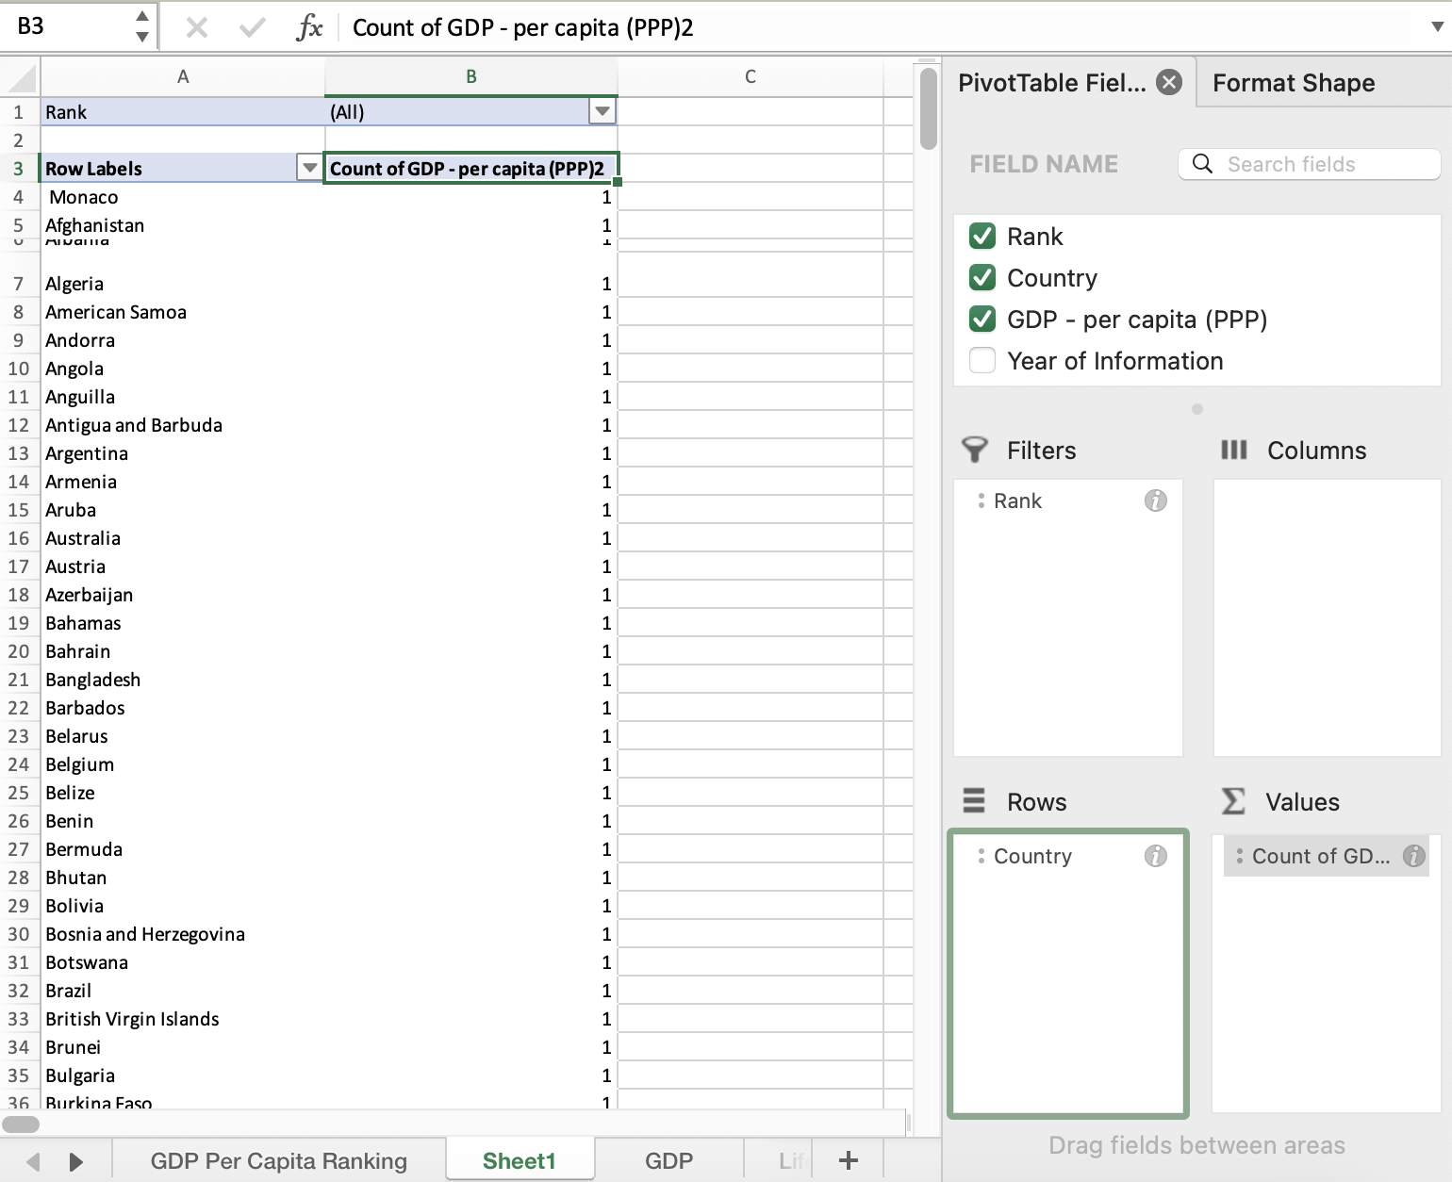

Apply filter to the Rank column and select Ascending.

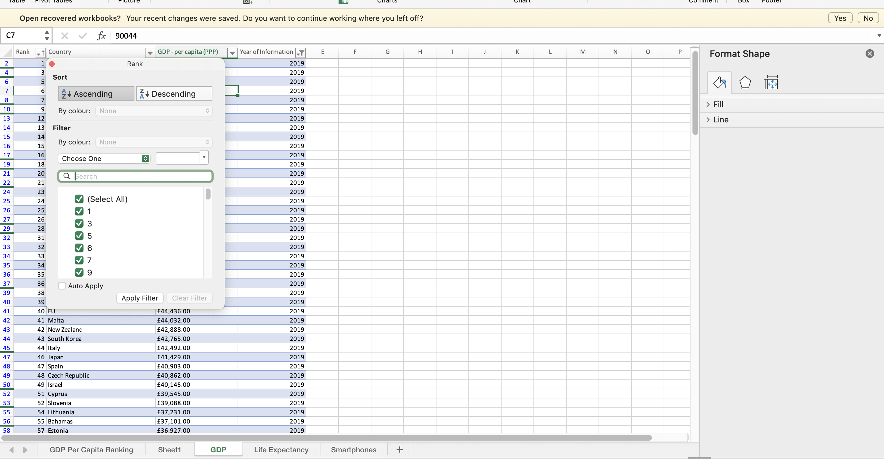

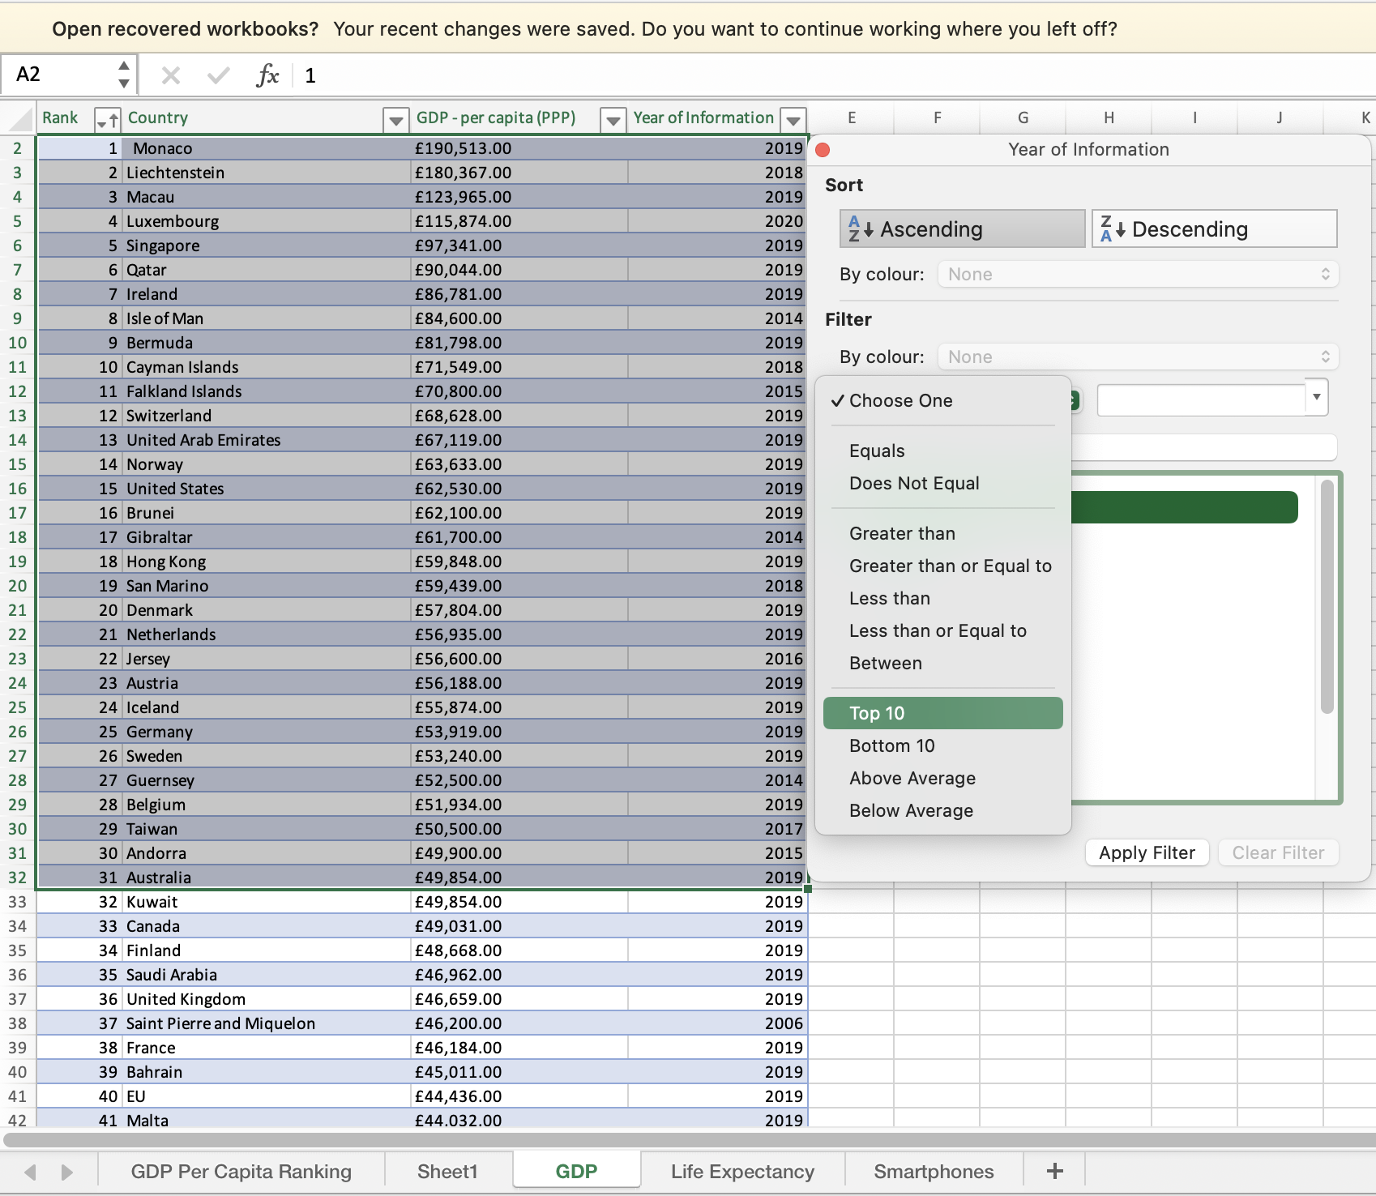

Select filter and change Top 10 to 20 items to display the top 20

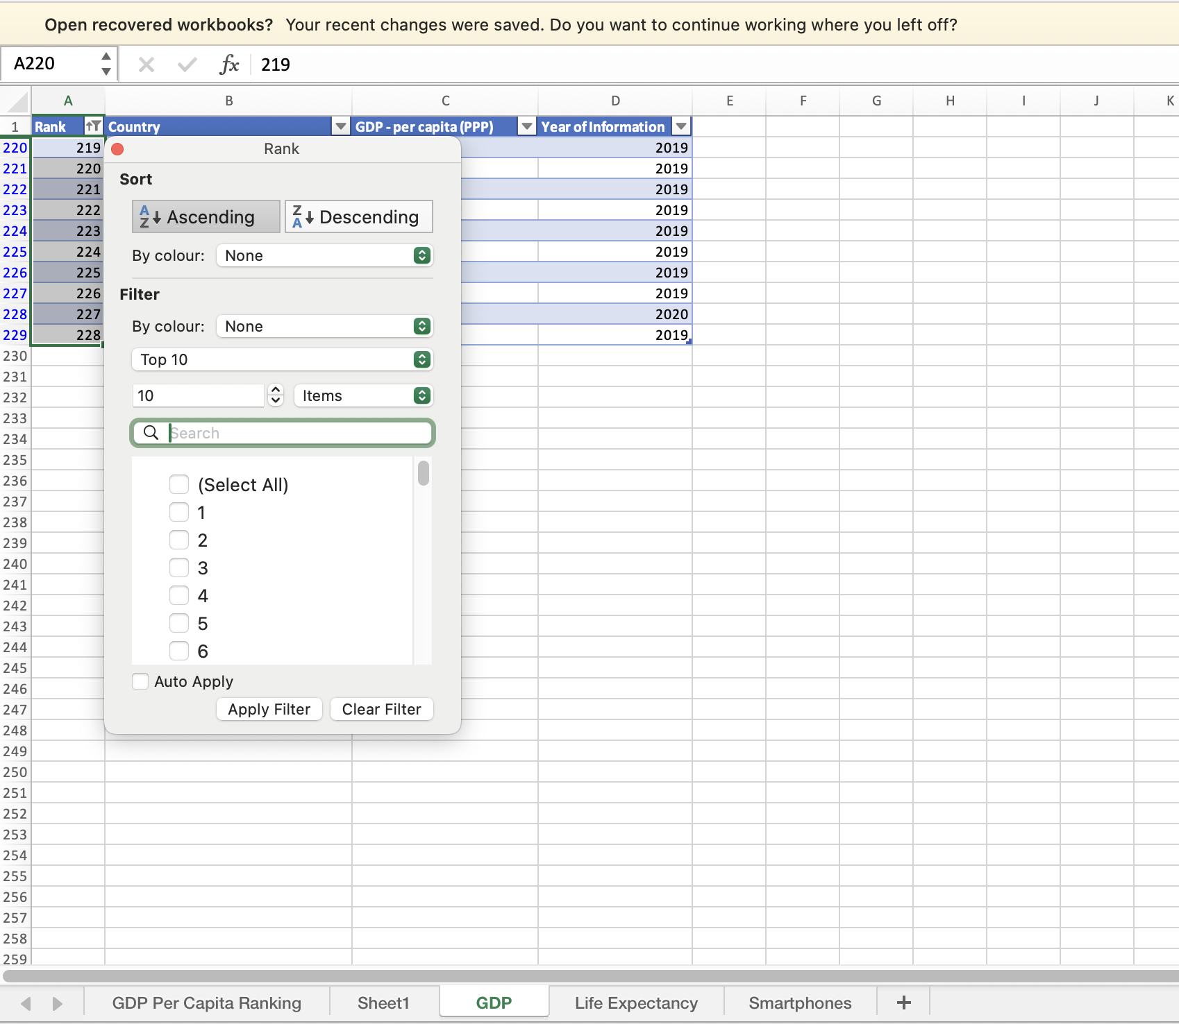

The Top 20 is returned:

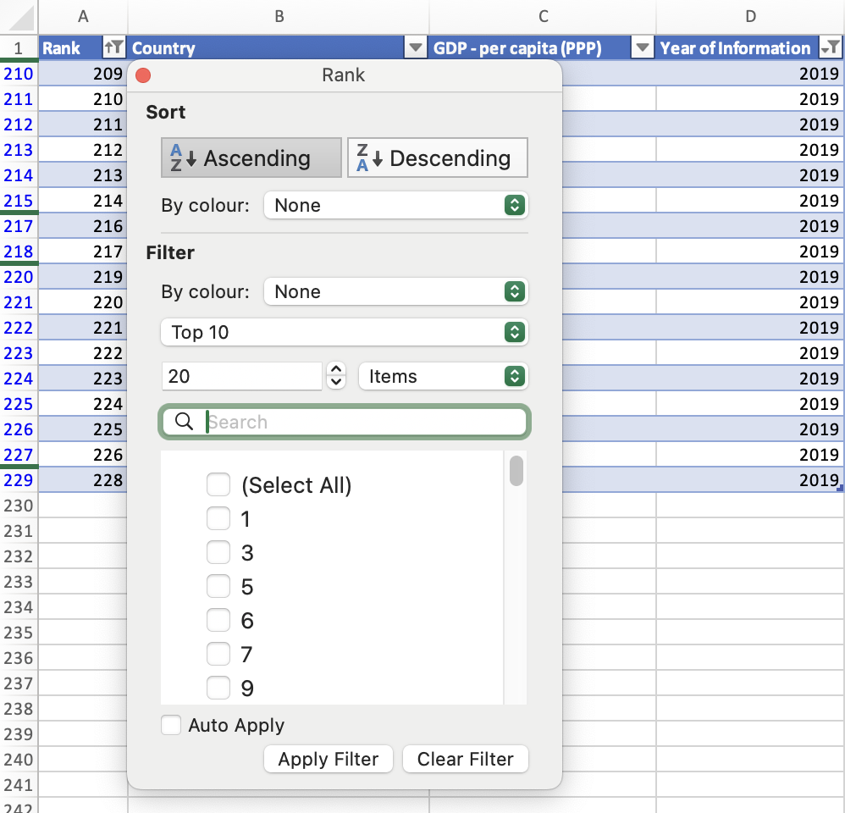

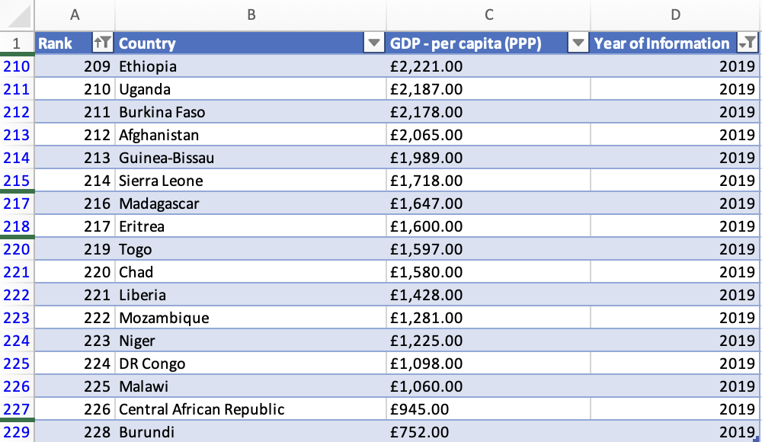

### 9. Next create a new Bar chart to display the 20 highest ranking countries from the sort.

Select the data, the from the insert menu Bar Chart

### Colour the background by highlighting the area underneath the table as shown below.

Find the add a fill colour icon and select a colour.

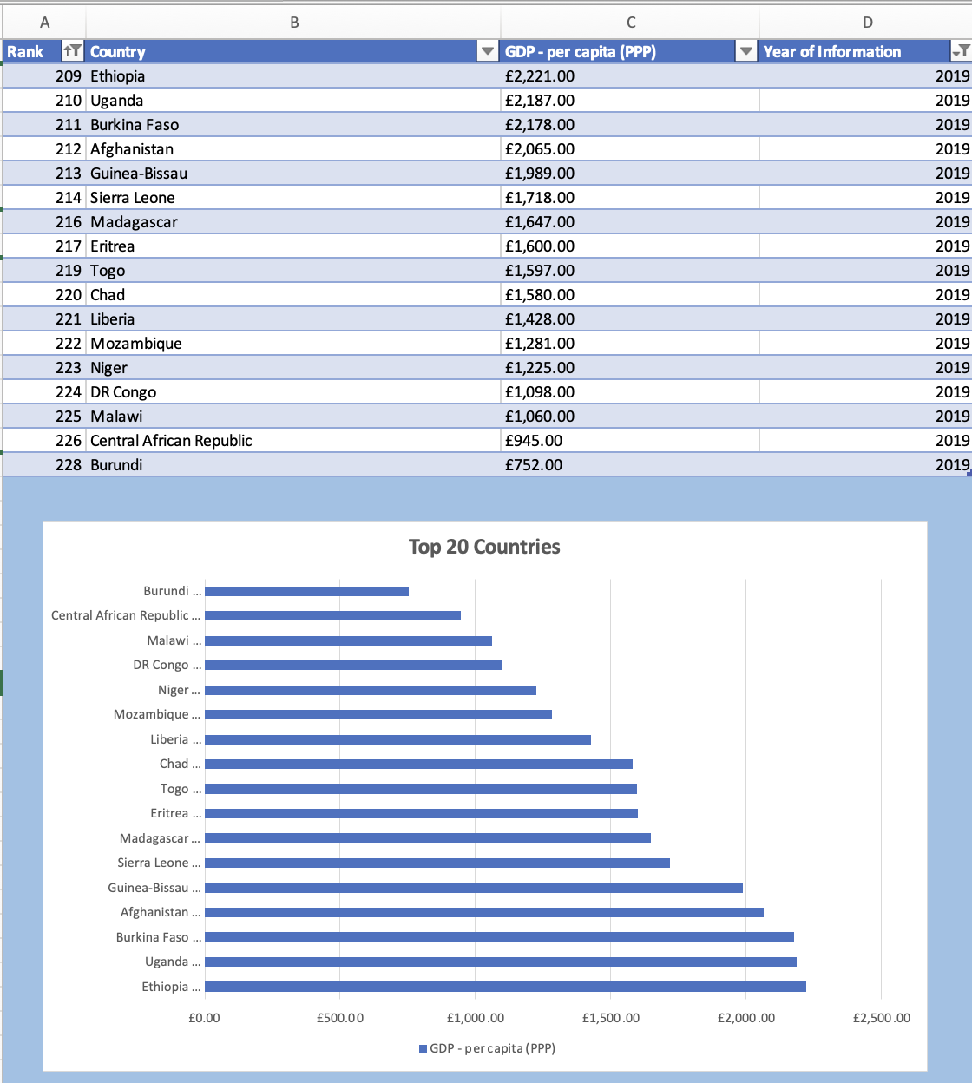

## Task 3 - Tableau

Workflow for Data Visualisation:

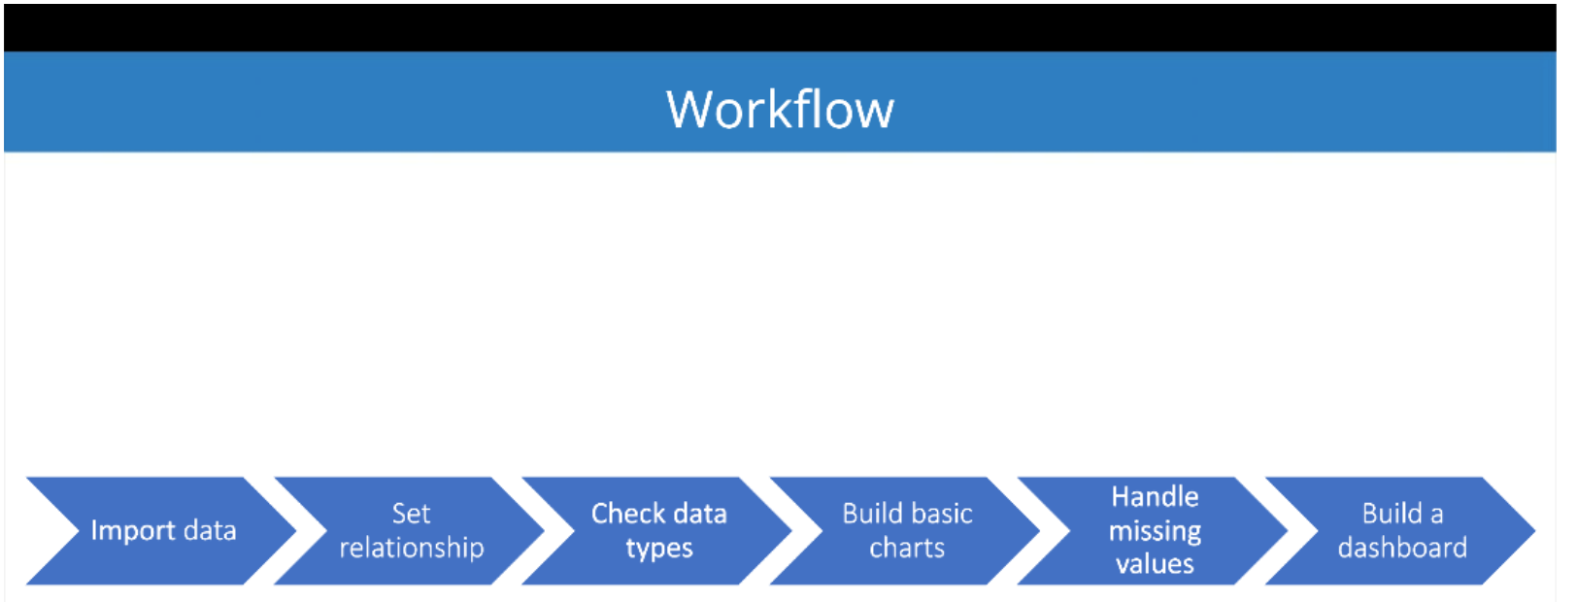

### Import Data

Open the Wealth of Nations spreadsheet in Tableau public.

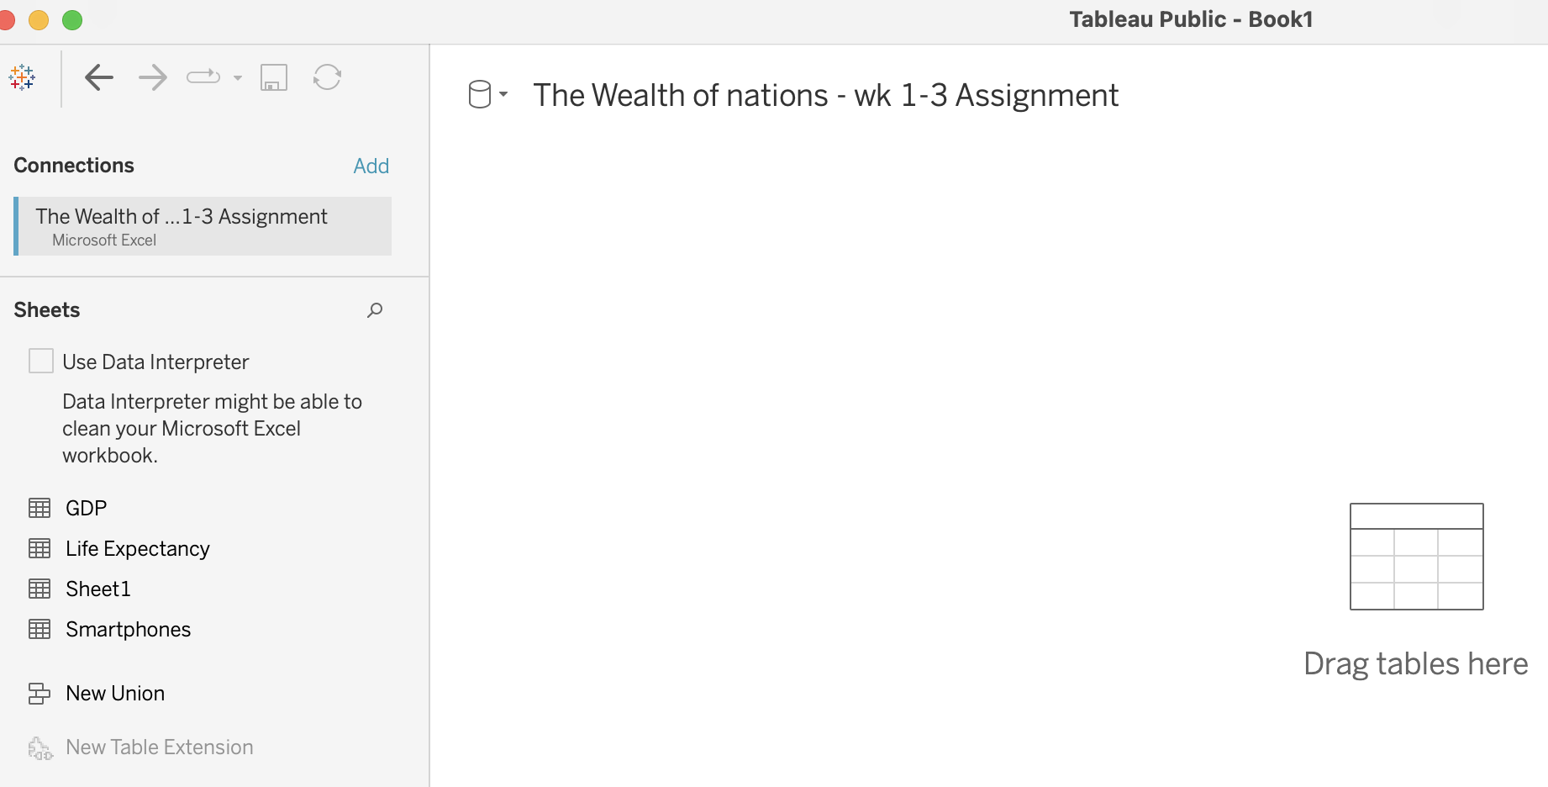

### 2. Set Relationships

You have three sheets and the common column for all of them is country, so the visual arrangement of the sheets does not matter.

Only the columns that you use to create the relationship matters. You can arrange the sheets in a straight line as seen below:

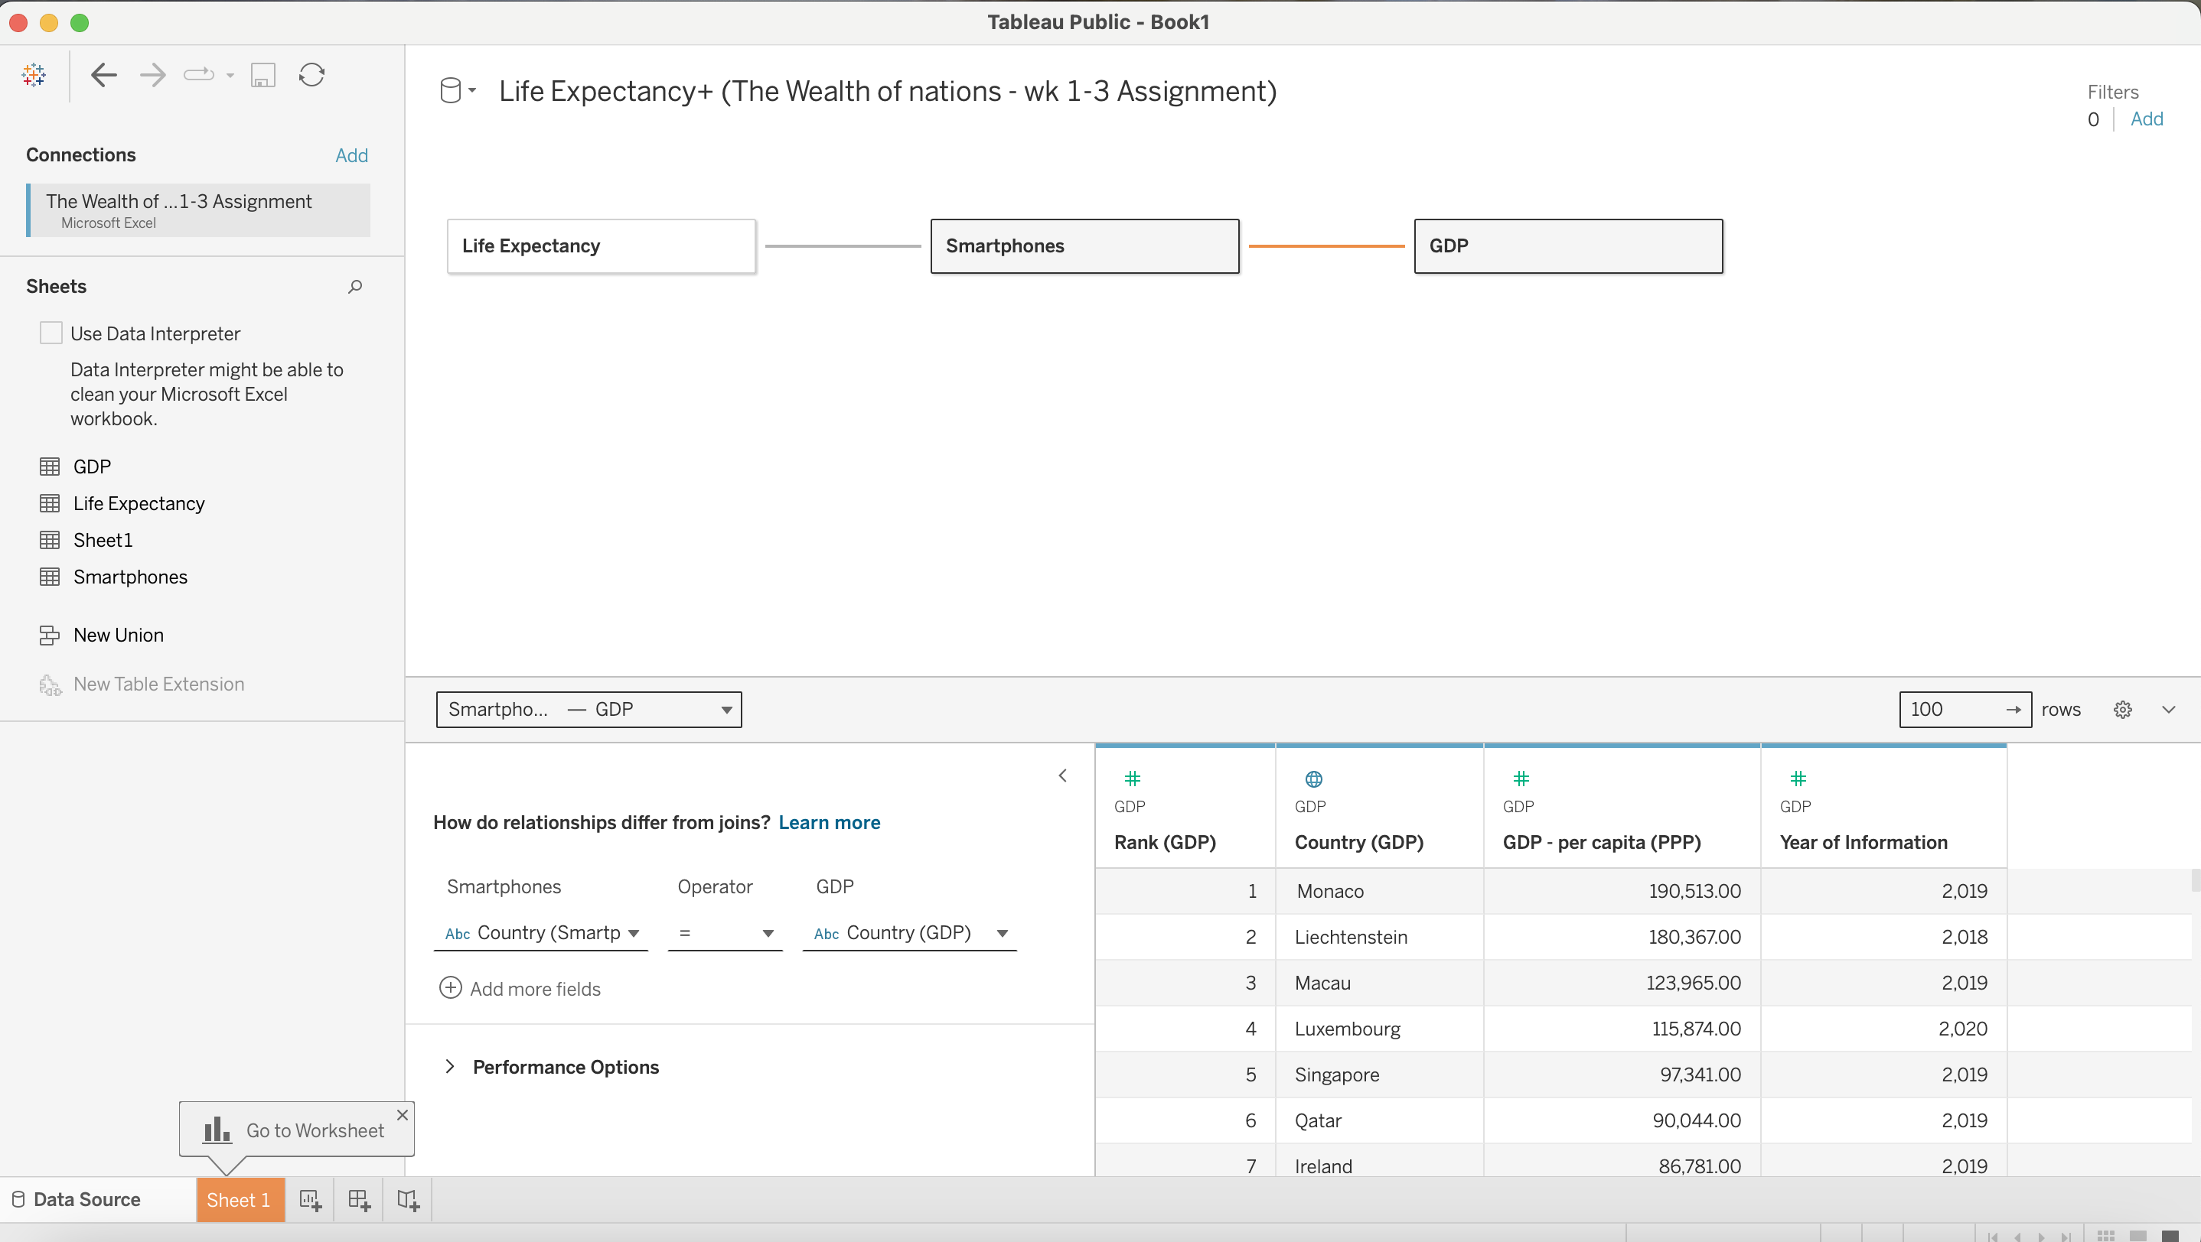

Or you can arrange it like this:

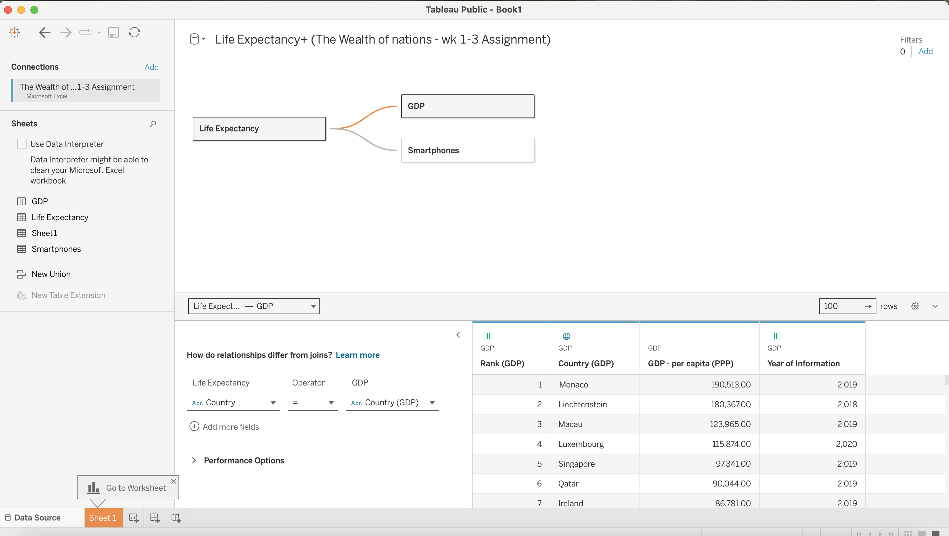

### 3.Data Types

Data types have been checked as below:

* Once your data is imported into Tableau, go to the 'Data Source' tab.
* Ensure that each field has the correct data type (string, number, date, etc.) assigned to it.
* Ensure the 'Rank' field can be recognised as a number as we are going to sort or filter by it.

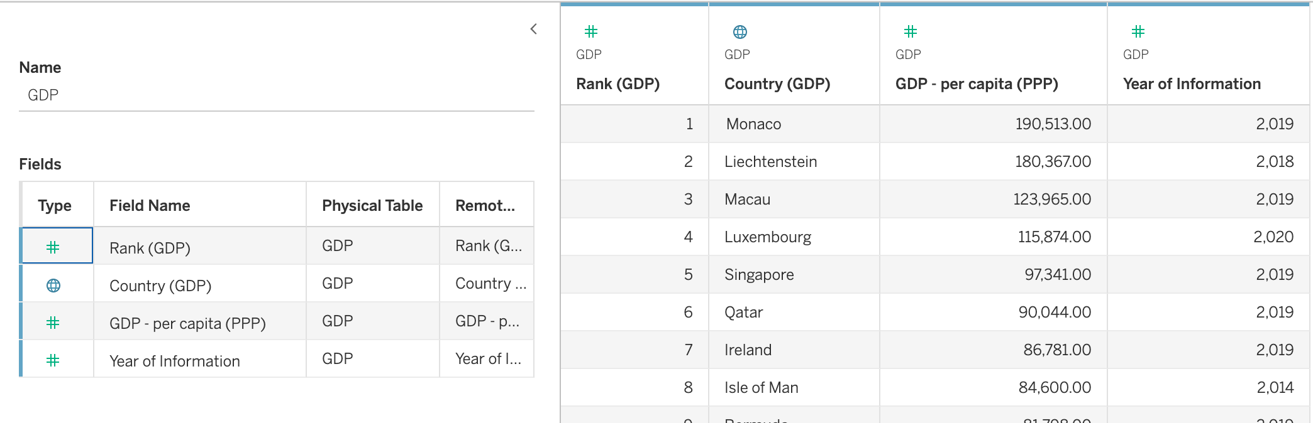

### 4. Build charts

Filter for Top 20 Highest Ranking Countries:

* In the 'Data' pane, right-click on the 'Rank' field and select 'Create Calculated Field'.
* Name this field 'Top 20 Rank' and enter a formula such as IF [Rank] <= 20 THEN "Top 20" ELSE "Other" END.
* Drag this calculated field to the 'Filters' shelf and select only 'Top 20'.

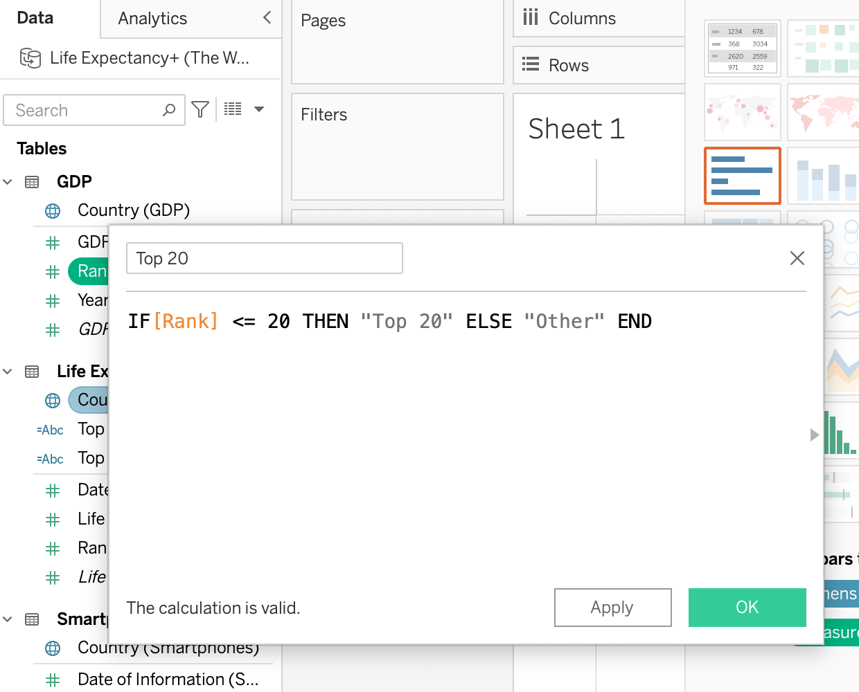

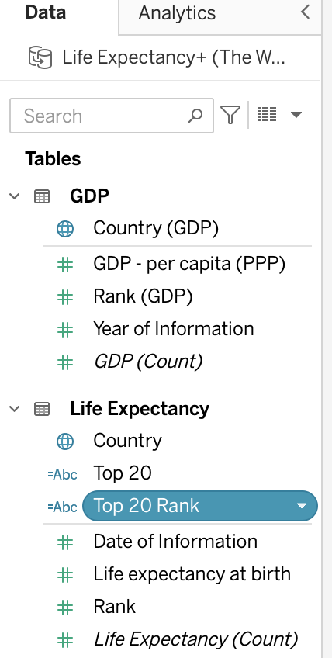

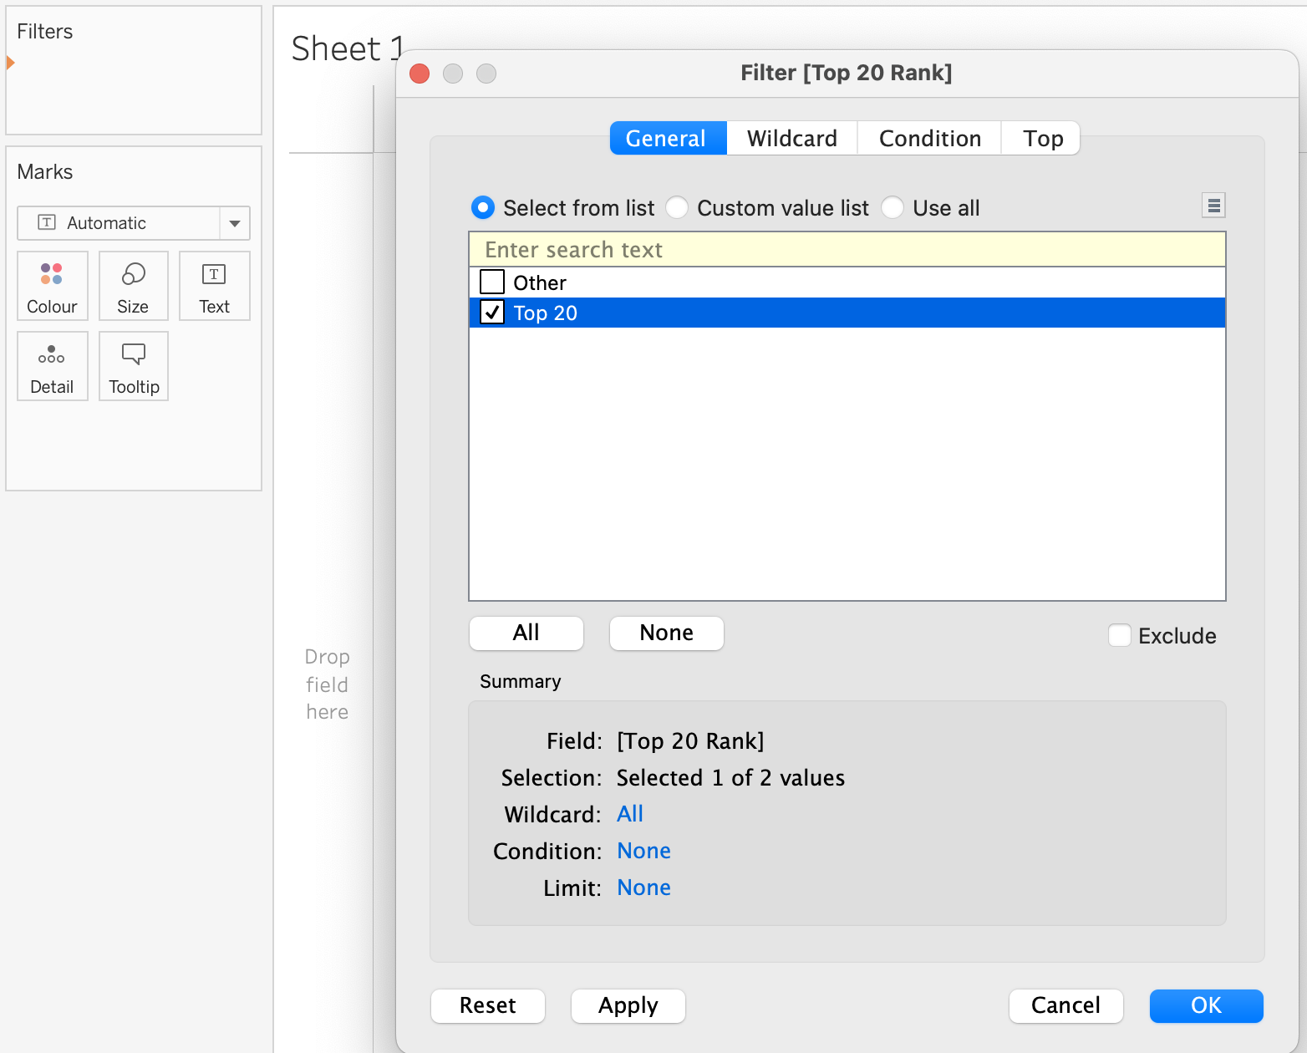

#### Build Charts:

* + When creating the visuals, use colours that are distinguishable by someone with colour blindness. Avoid problematic colour combinations like green/red or blue/purple.
  + Use patterns or shapes in addition to colours to help differentiate data points.
    1. Visuals were created:
       - * A bar chart showing GDP per capita for the top 20 countries.
       - 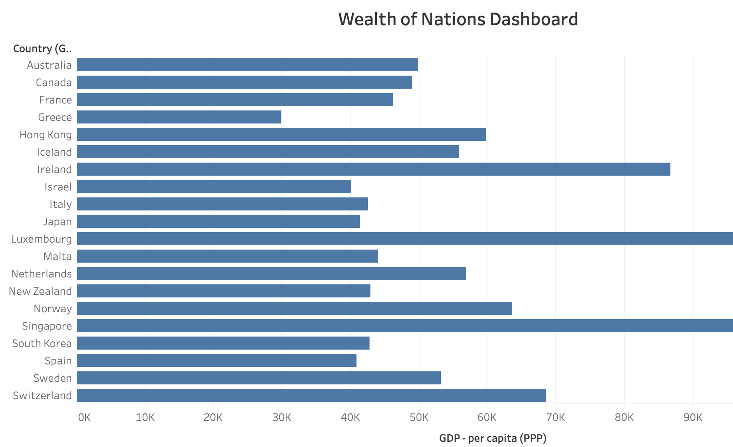

**Formatting**: Colour blind colours were selected

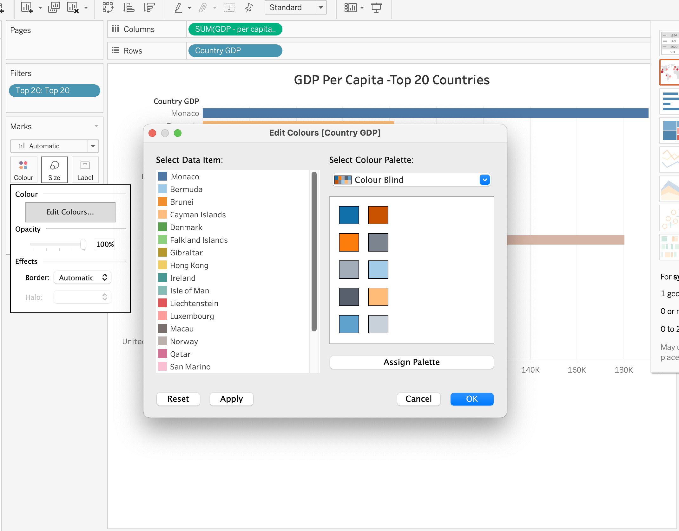

* + - * A map visual of country highlighting geographical location of the top 20 countries.

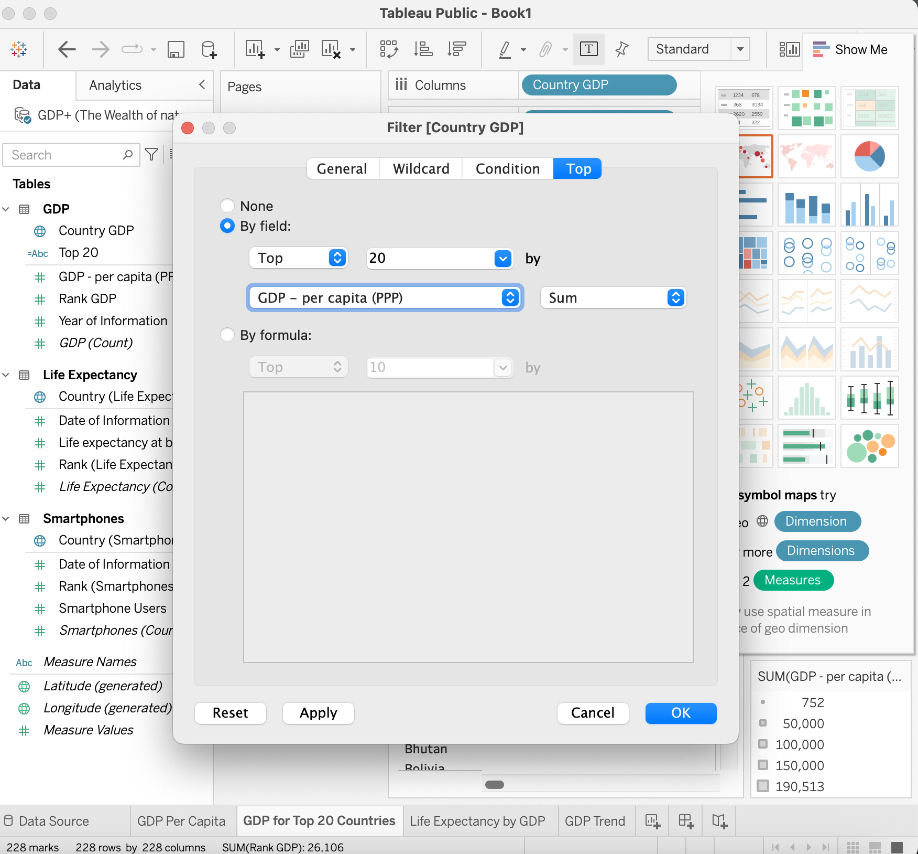

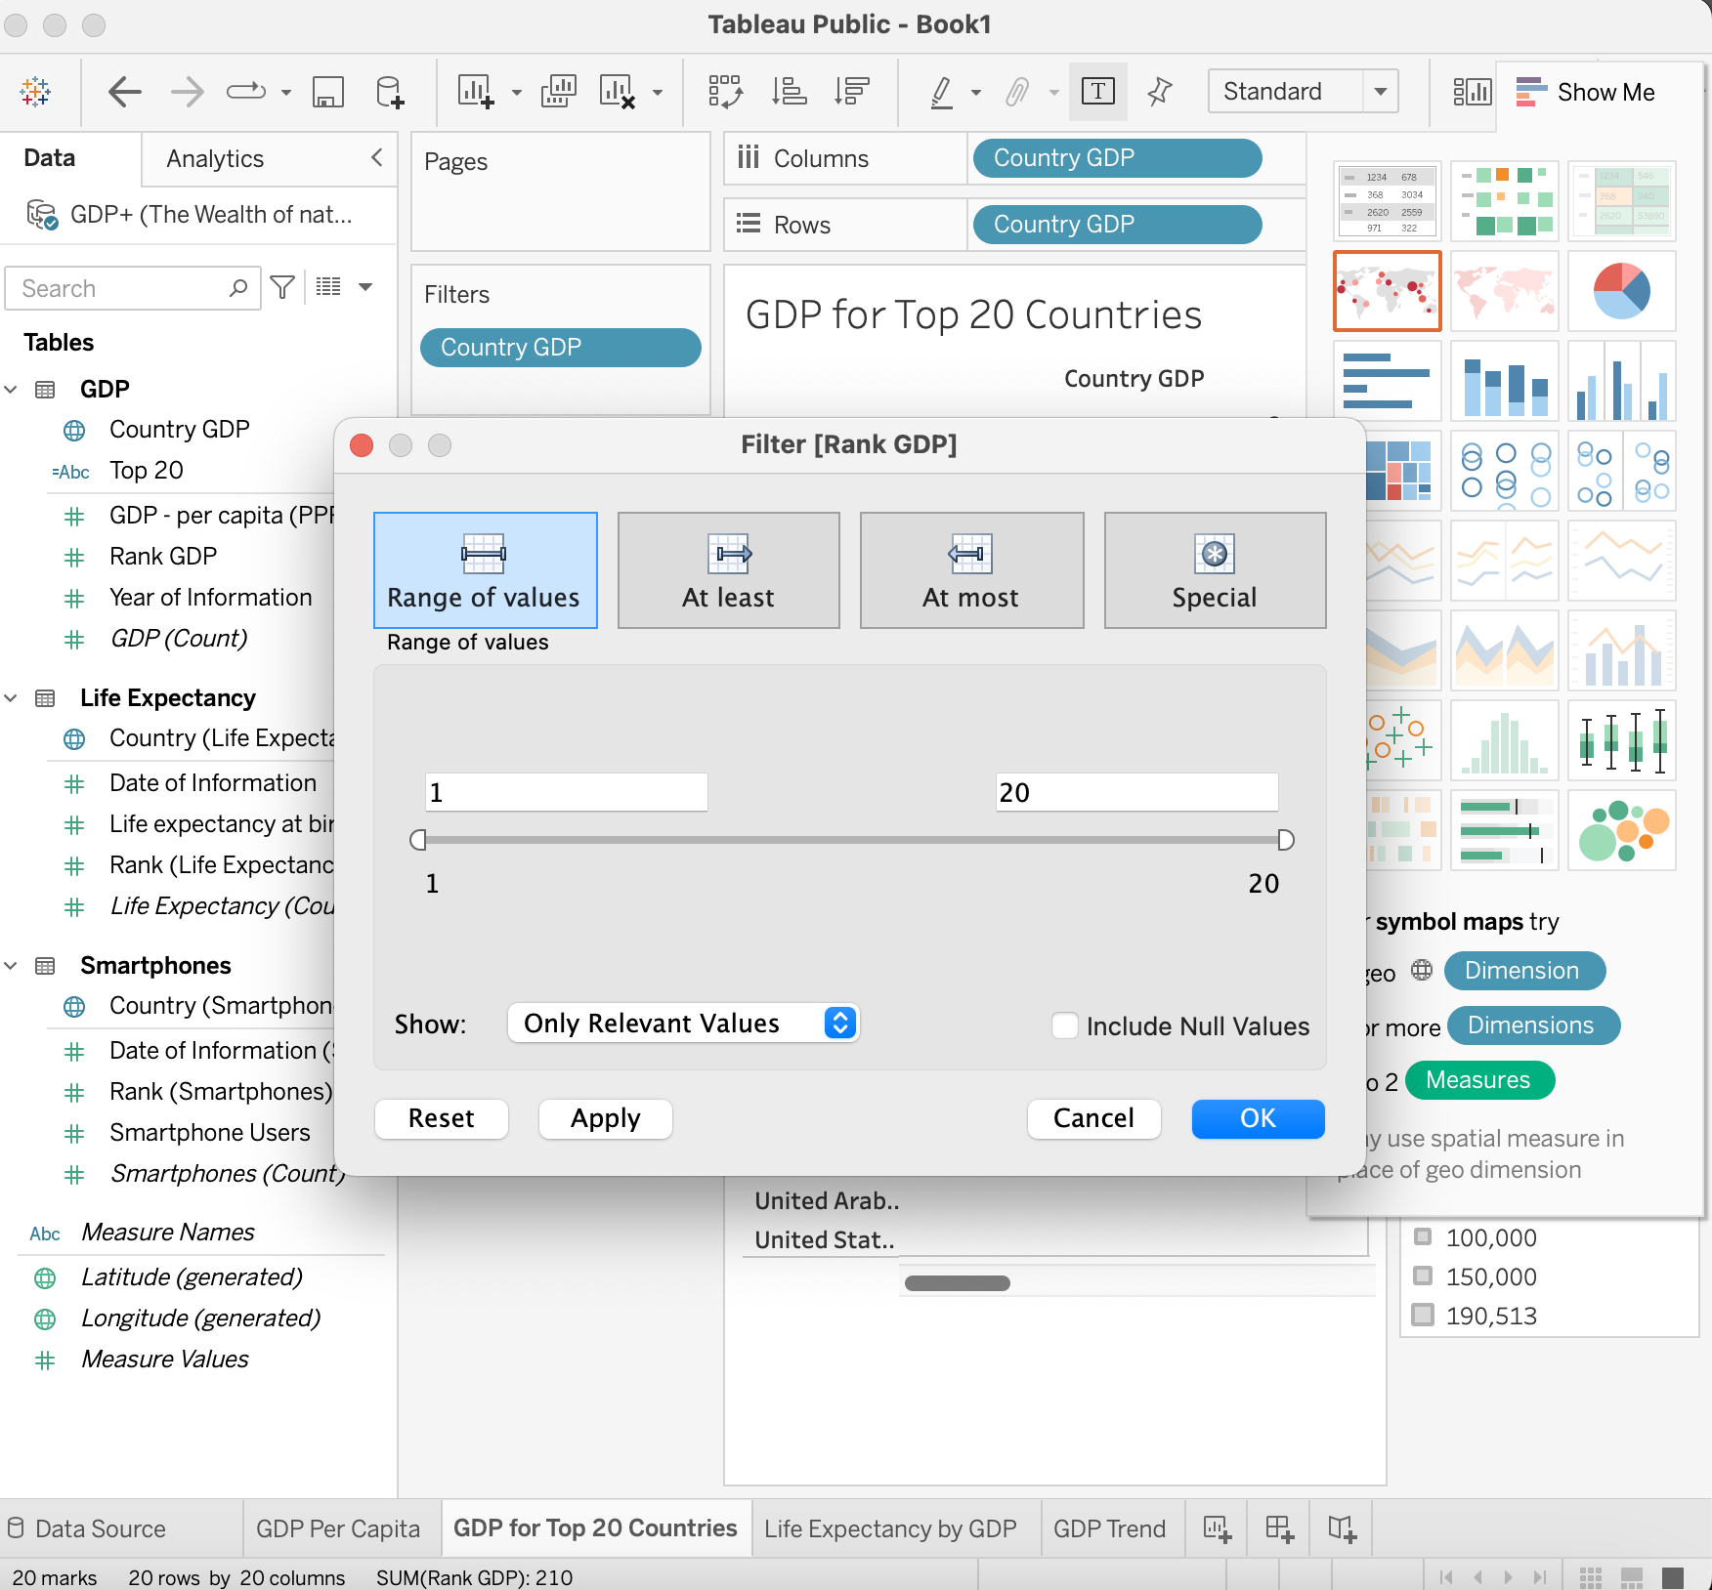

**Formatting**: Map background was set to Normal.

* + - * + A bar chart showing the life expectancy by GDP per capita for the top 20 countries.

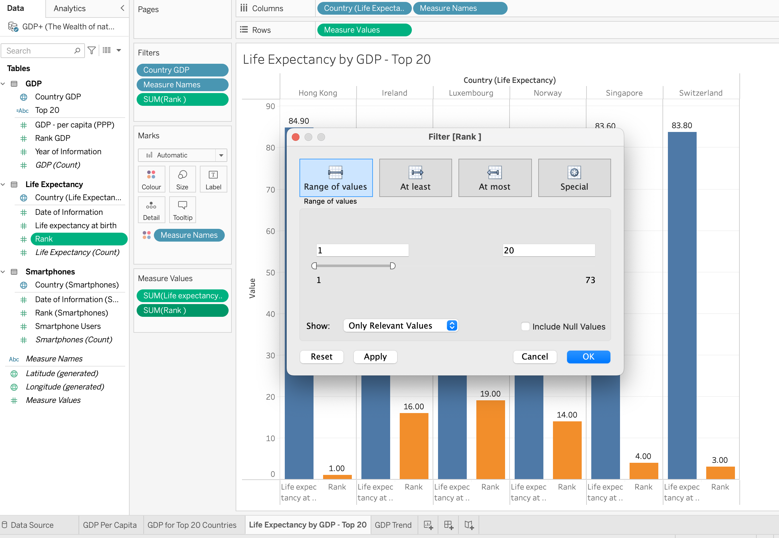

* + - * + A bar chart showing the smartphone usage by country for the top 20 countries. Country (column) and Smartphone Usage (row).

Calculated field created:

* + - * 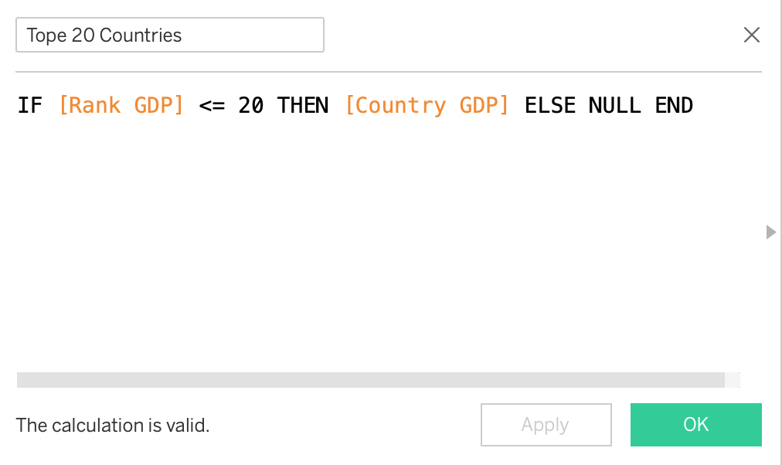

**Sorting**: Data was sorted - descending:

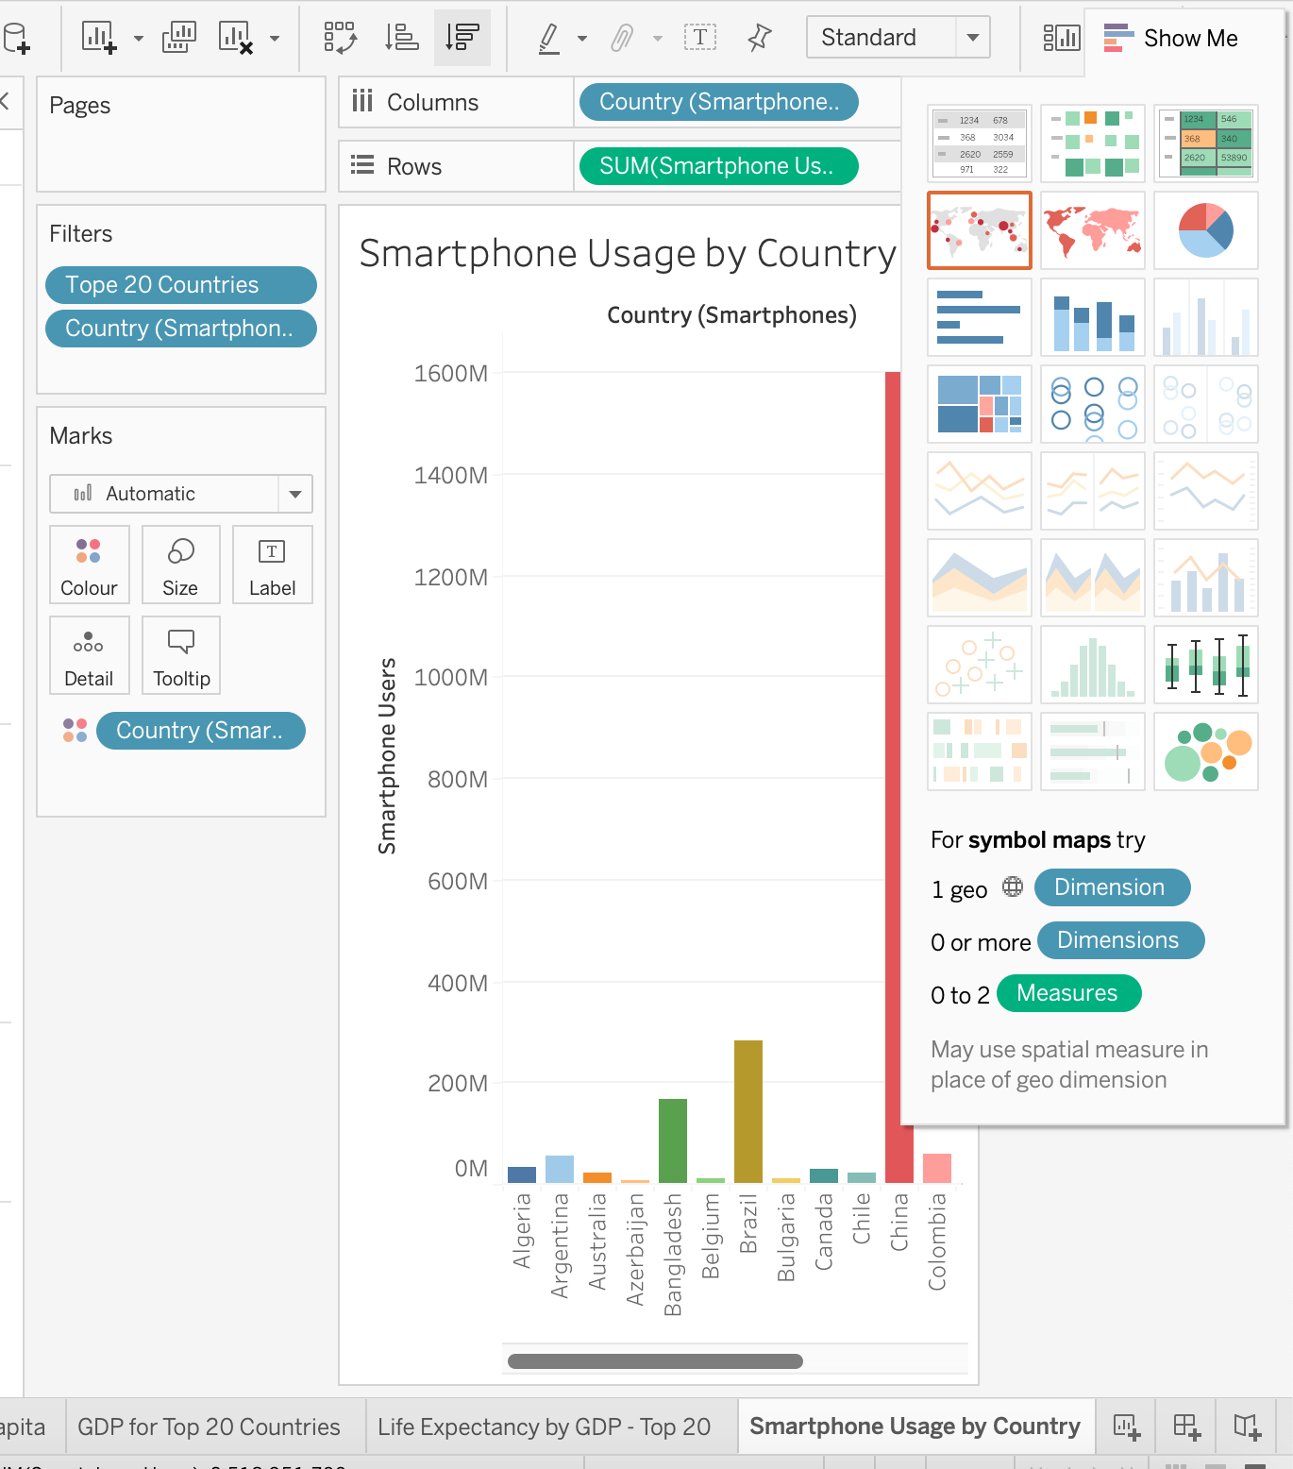

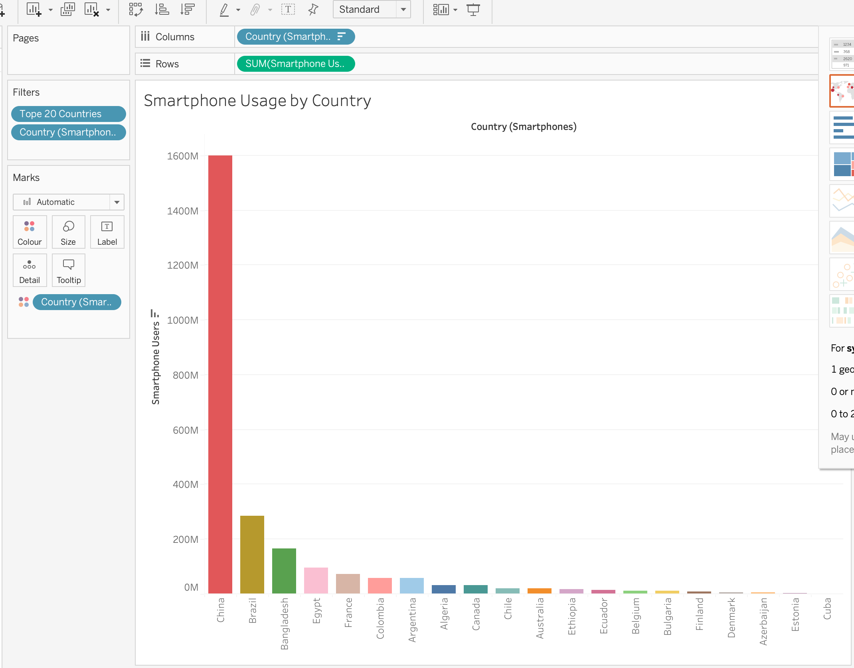

The bar chart was changed to a treemap to ensure the dashboard had a variety of charts visualising the data.

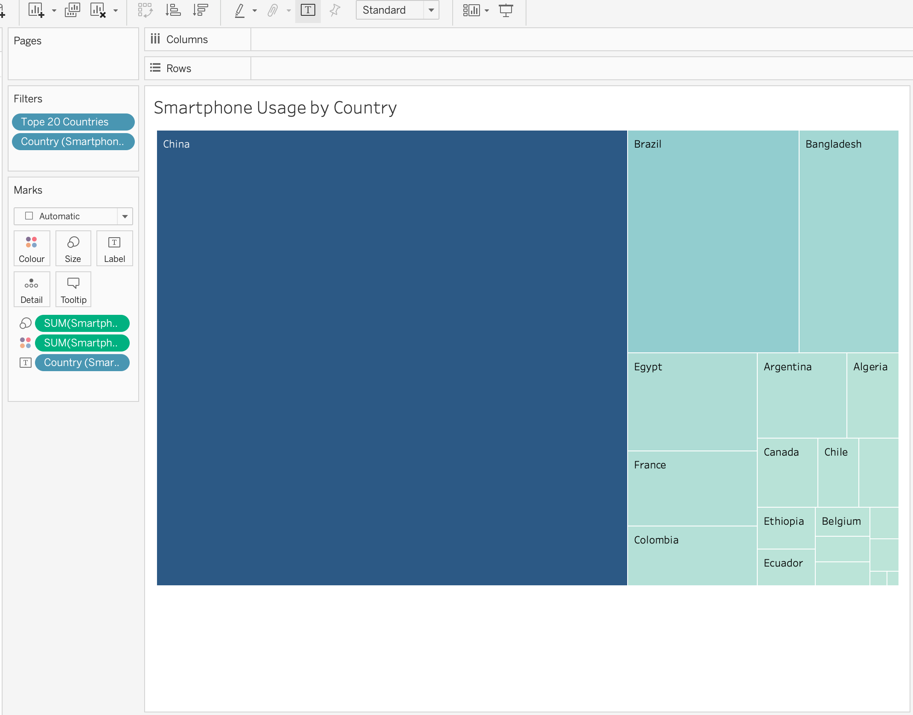

Symbol was added to text for the appropriate currency.

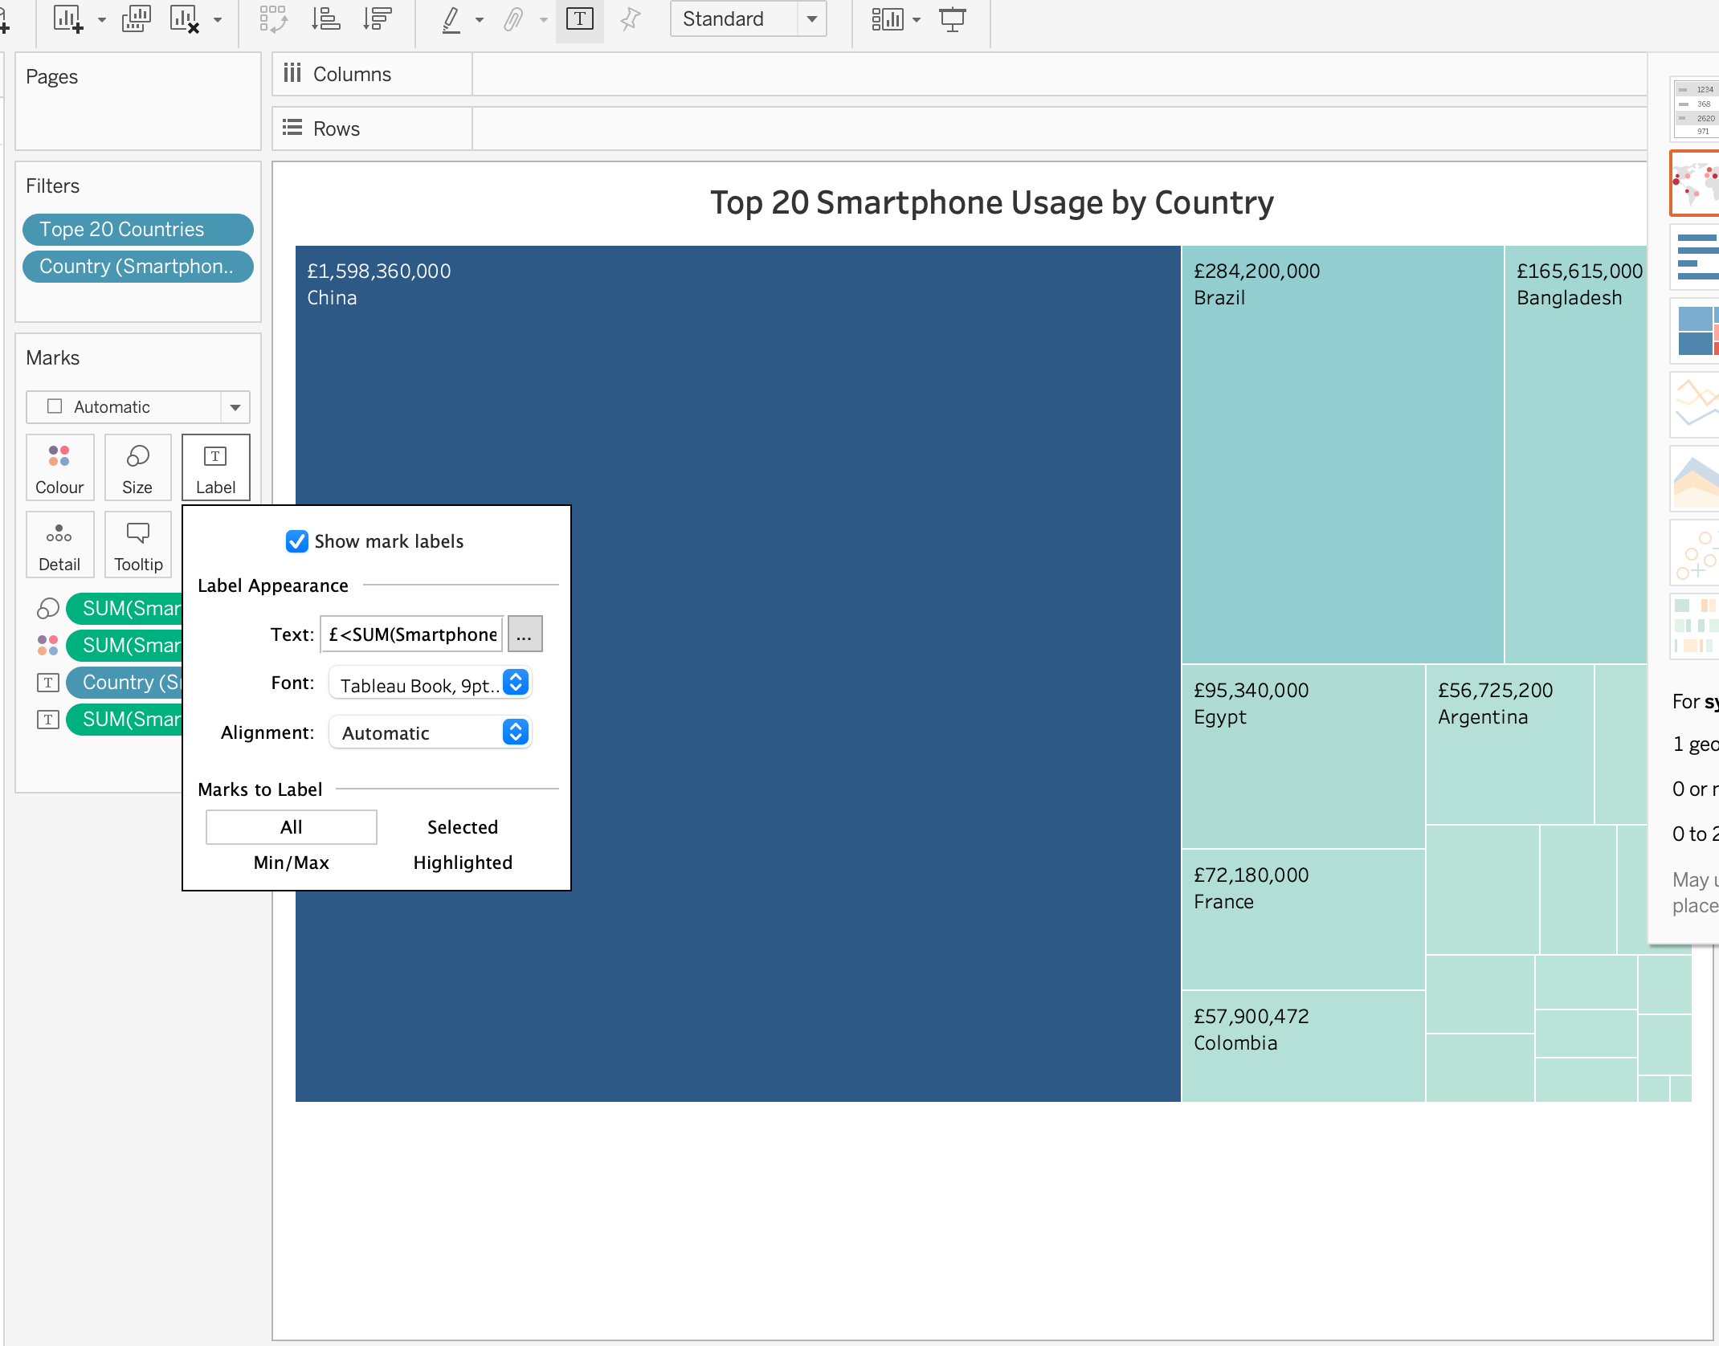

**Colour Adjustments:**

* 1. To accommodate colour blindness, colour was adjusted to a high-contrast colour palette. Tableau provides colour palettes that are optimised for colour blindness.

**Formatting**:

* 1. Charts have clear labels and titles.
  2. Format the axes and ensure that all text is legible.
  3. Tooltips were added to provide additional information when users hover over each bar/section.

#### 5) Null Values

As you create your charts, if you see a little gray box containing a count of null values, select the filter option. I did not see this option.

#### 6) Dashboard

* 1. Once the charts were created:
     + The ‘Dashboard' tab was selected at the bottom of the screen.
     + Visuals were dragged and dropped onto the dashboard canvas.
     + The charts were arranged in a layout that tells a clear story about the data.
     + The dashboard was decluttered, and all visuals are easily readable.
     + An attempt was made to use filter dashboard actions to make your dashboard interactive and to allow for drilling down into the data.

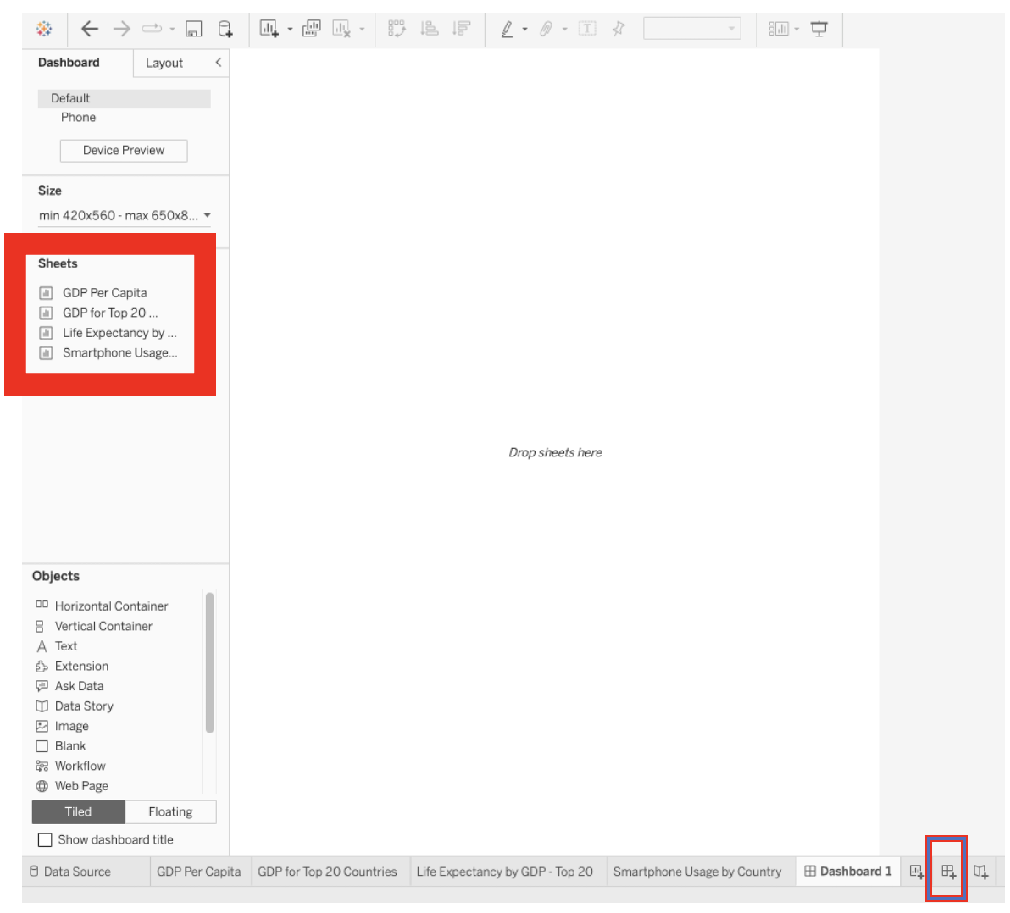

**Accessibility Considerations:**

* Keeping accessibility in mind, text was made bold to be readable, contrast was created on the dashboard.
* Tooltips were used effectively to provide additional information when hovering over parts of the visuals.

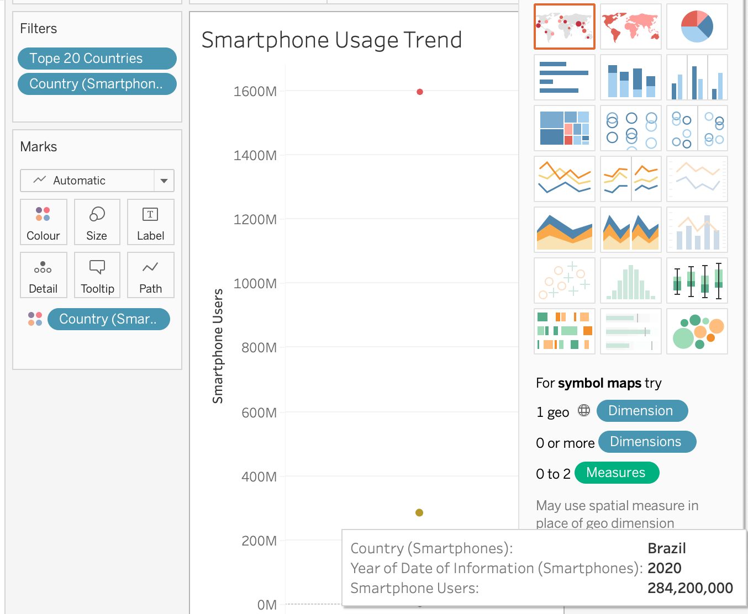

* The dashboard's colour scheme was tested with an online colour blindness simulator (Coblis — Color Blindness Simulator) to ensure it is readable for all types of colour vision deficiencies. An image of the dashboard was uploaded to see how it would look to someone with different types of colour vision deficiencies. This was a useful way to ensure that the design is accessible to all users.
  + Testing below shows the most prevalent deficiency: Anomalous Trichromacy: Green-Weak/Deuteranomaly

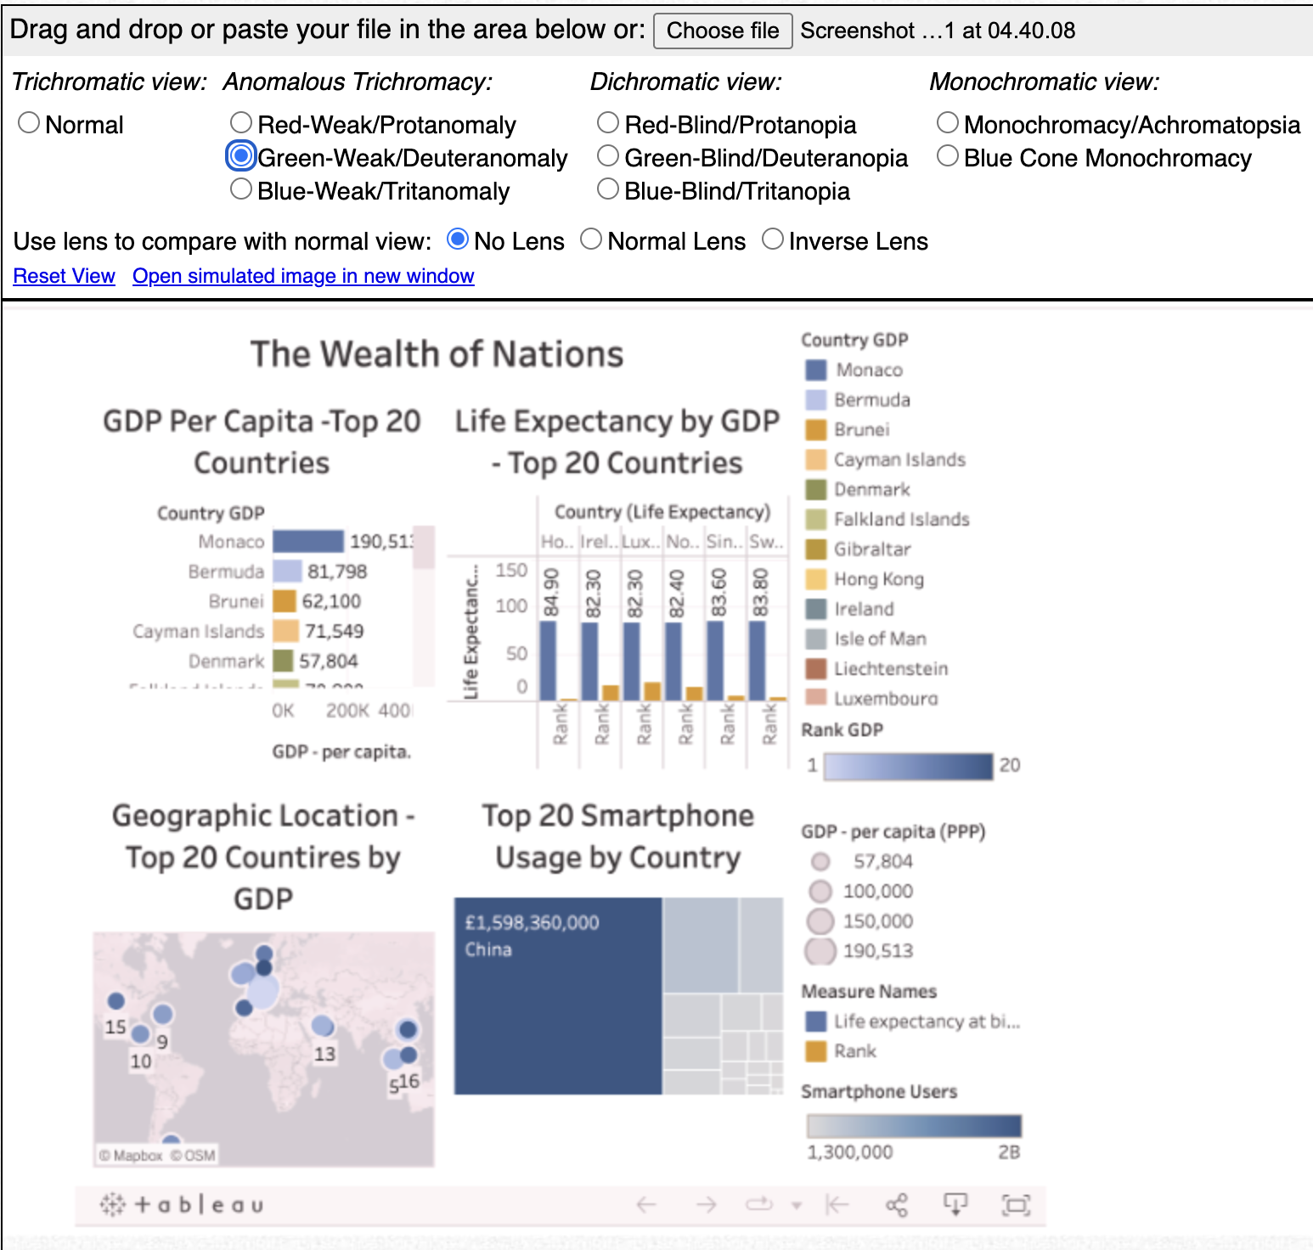

Original:

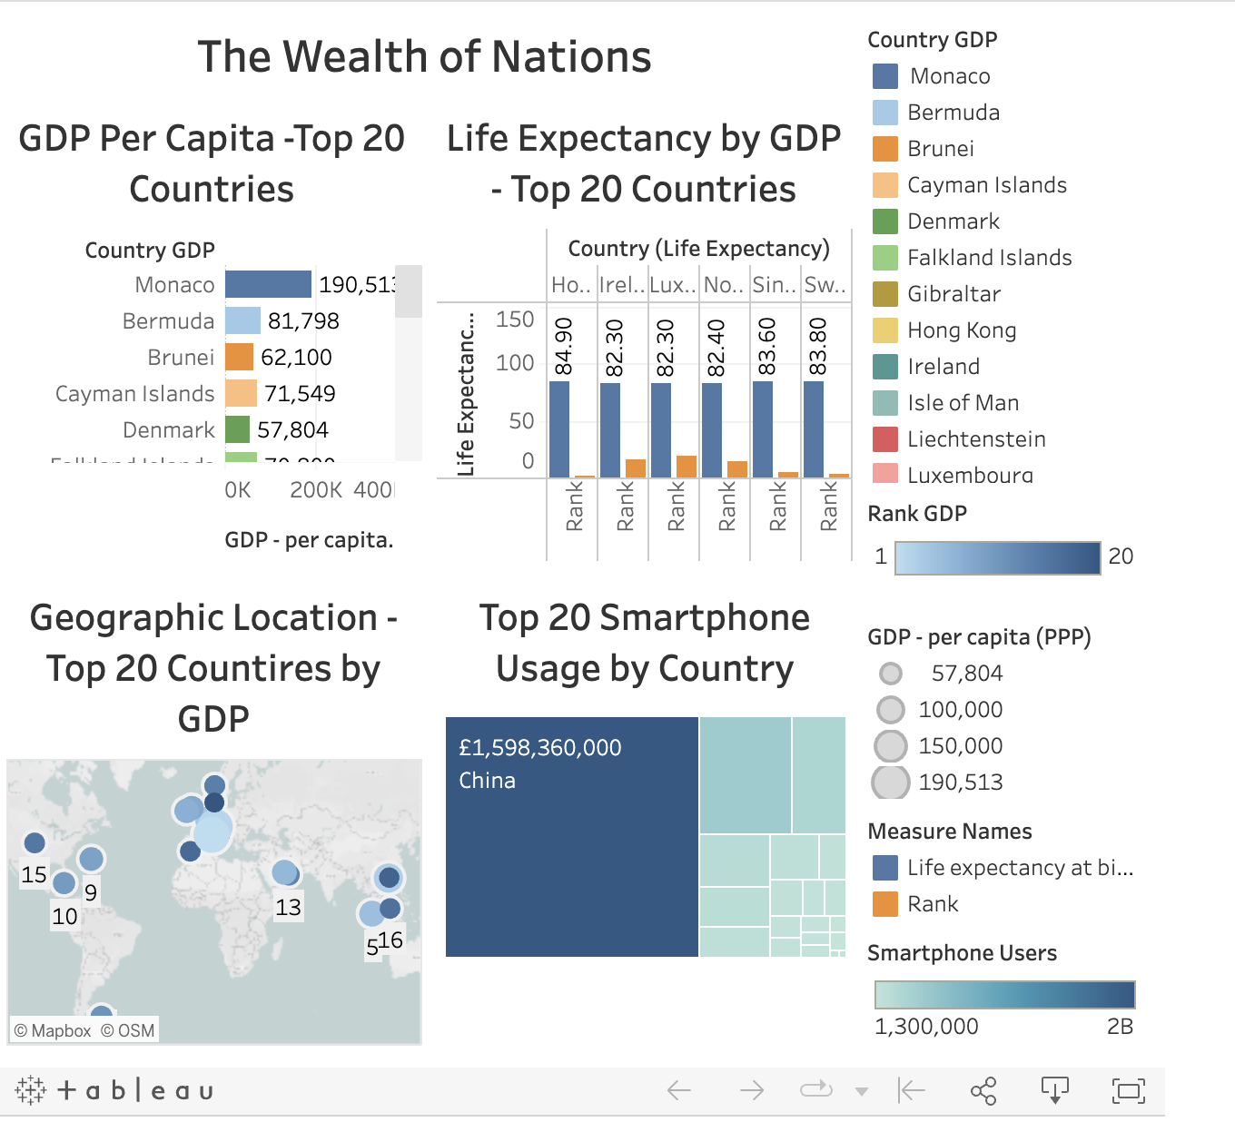

#### Screenshot of Dashboard:

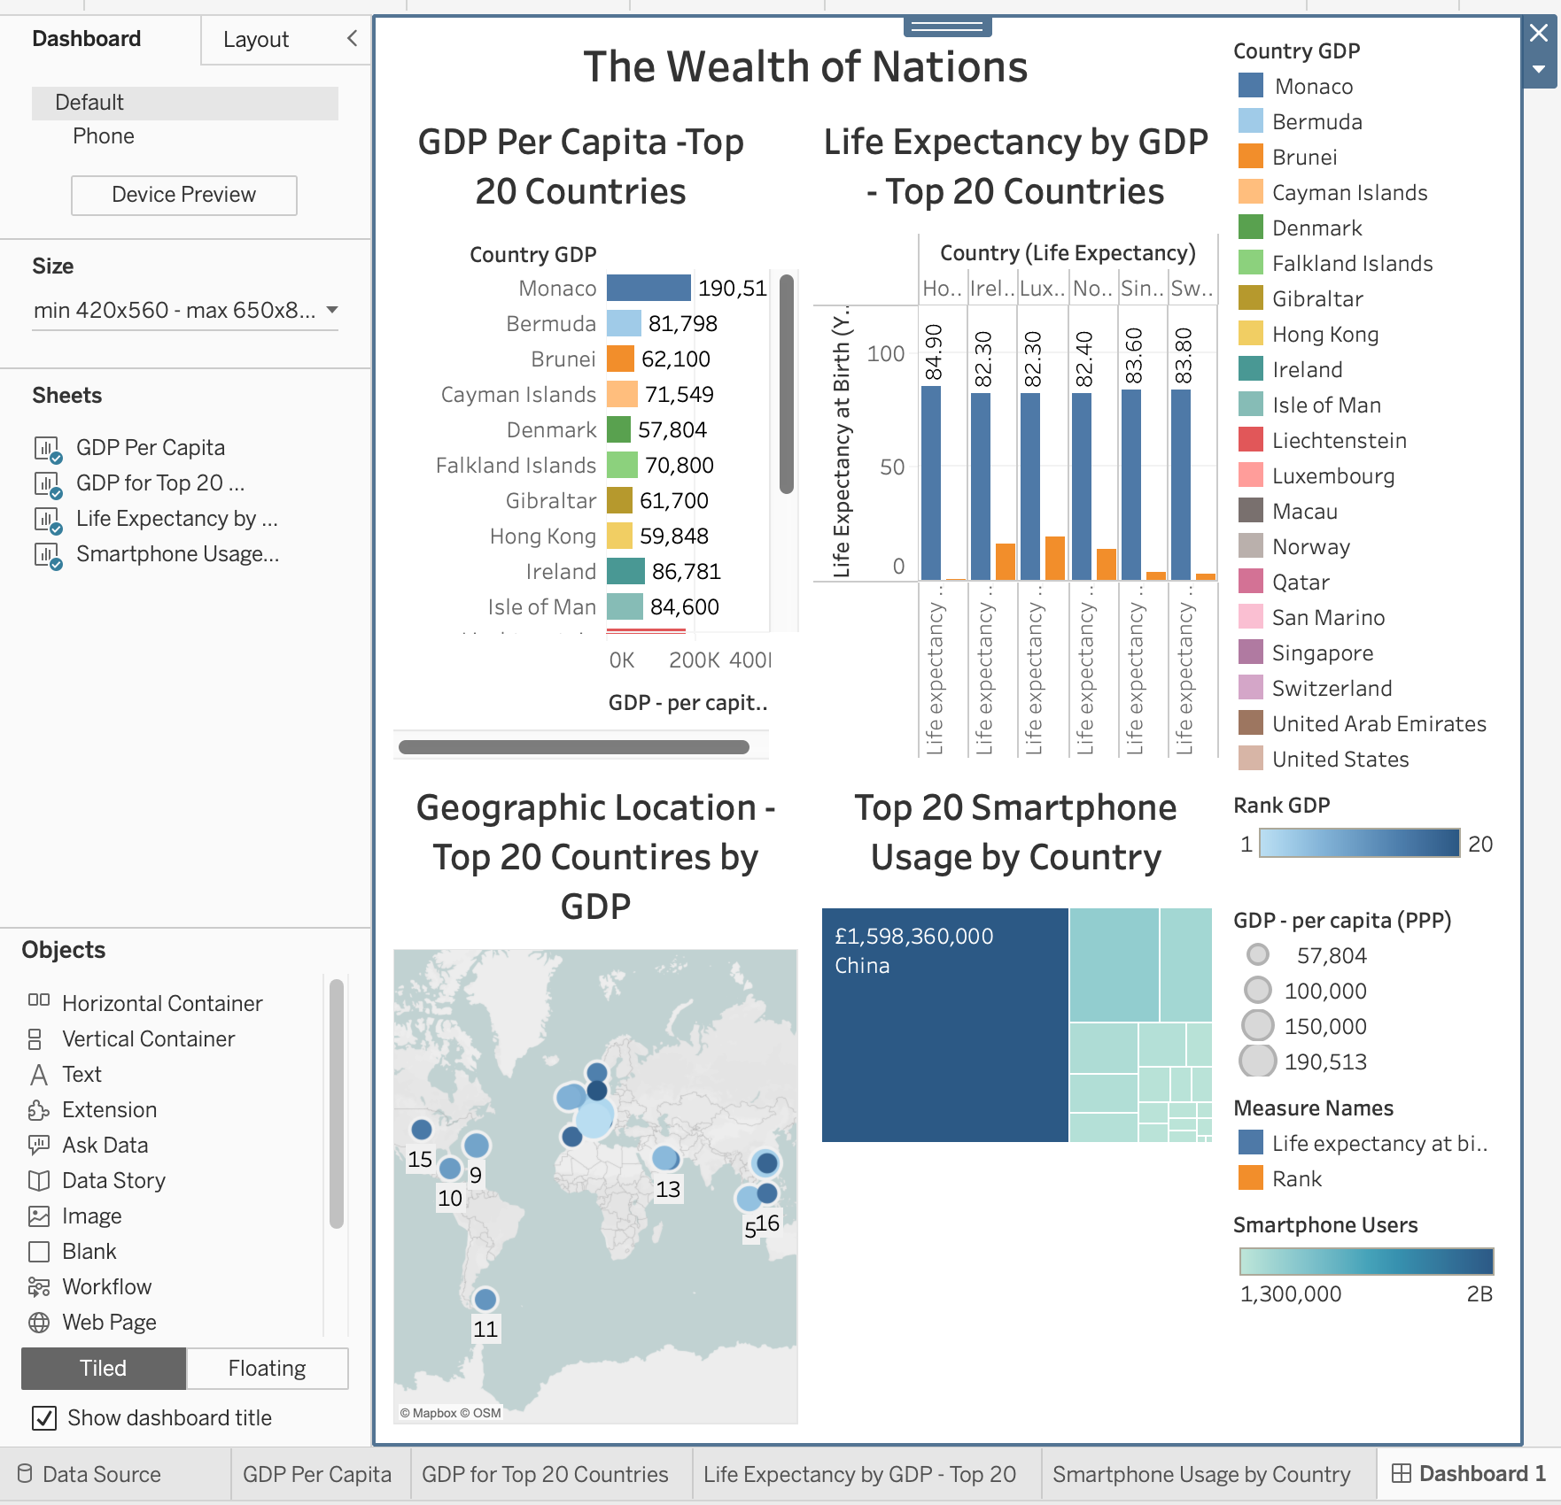

#### Link to Dashboard:

<https://public.tableau.com/shared/5H55W6H9H?:display_count=n&:origin=viz_share_link>

<https://public.tableau.com/views/TheWealthofNations-AssignmentWeek1-3V1_1/TheWealthofNations?:language=en-US&publish=yes&:display_count=n&:origin=viz_share_link>

#### Personal Reflection:

After receiving an extension for my Tableau and Excel assignment, I found myself grappling with a mix of anticipation and apprehension. Missing a crucial Tableau class had set back my confidence, and the fleeting availability of the class video only added to my unease. Despite these challenges, I committed to the task at hand, driven by the necessity to not only complete the assignment but also to expand my analytical prowess.

The Excel component of the assignment served as a solid foundation, allowing me to hone my skills in sorting, filtering, and crafting tables with precision. The familiarity of Excel's environment was reassuring, and the successful completion of this section bolstered my self-assurance.

Transitioning to Tableau, I navigated initial doubts about my capability to effectively use the tool. However, as I delved deeper into the assignment, constructing visuals and dashboards, my proficiency grew. The process was enlightening, revealing the transformative power of data when conveyed through compelling visualisations.

Through trial, error, and exploration, I learned to manifest abstract data sets into informative and aesthetically pleasing charts. The principles of data privacy and accessibility were not just theoretical concepts but practical necessities that I learned to integrate into my work, ensuring that my dashboards were not only insightful but also inclusive, catering to users with cooler vision deficiencies.

Reflecting on this journey, the extension became less of a delay and more of an opportunity for growth. This assignment has been more than a bootcamp requirement endeavour; it has been a pivotal learning experience, reinforcing my resolve to pursue data visualisation with vigour and confidence.

## Judging Criteria

| **Criteria** | **Description** | **Maximum Marks** | **Evaluator's Score** |
| --- | --- | --- | --- |
| **Excel Part** |  |  |  |
| Getting Started |  |  |  |
| - Sorting and Filtering | Ensure data is easy to understand |  |  |
| - Table Creation | Organise information neatly |  |  |
| Playing with Data |  |  |  |
| - Formulas and Functions | Use simple formulas for basic calculations |  |  |
| - Charts | Create easy-to-read charts to show trends |  |  |
| - Keep it Safe | Set a password to protect sensitive information |  |  |
| Showcasing Work |  |  |  |
| - Explain Your Steps | Help others understand what you did |  |  |
| - Make it Look Nice | Arrange things neatly, so it's easy to follow |  |  |
| **Tableau Part** |  |  |  |
| Working with Data |  |  |  |
| - Importing Data | Bring your Excel data into Tableau |  |  |
| - Table Relationships | Connect related information in Tableau |  |  |
| Making it Visual |  |  |  |
| - Designing Visuals | Create good-looking charts and graphs |  |  |
| - Finding Insights | Find interesting stuff in your data |  |  |
| - Click and Explore | Make it interactive so others can play around |  |  |
| Explaining Your Work |  |  |  |
| - Tell Your Story | Explain what you did in simple terms |  |  |
| **Total** |  |  |  |